UNIVERSITY OF NAIROBI.

COLLEGE OF AGRICULTURE AND VETERINARY SCIENCES. DEPARTMENT OF PUBLIC HEALTH, PHARMACOLOGY AND TOXICOLOGY. JLS 200: LEATHER TECHNOLOGY I (BSc-2ND YEARS)

Common terms we’ll be using from time to time you should be acquinted with;

Hide –the outer covering of a bovine animal eg cow, buffalo, horse, donkey, whale etc Skin –the outer covering of small animals eg goat, sheep, pig, crocodile, ostrich etc Green hide/skin –freshly flayed outer covering of bovine/small animal

Pickled hides/skin –hides/skins treated with acid to a lower pH for preservation or tanning Pelt –hides/skins limed

Leather –tanned hides and skins rendered non putrifiable

Leather Technology for quality materials as demanded by the customer. The quality improvement to start from;

Live animal - The damages caused during the time when the animal is alive which should be avoided are,

- Scars - caused by barbed wires, thorns, horns, brands etc.

- Infestations - Caused by warble fly, ticks, sarcoptic mange, dermodermic mange etc.

- Infections - Ringworm.

- Cockle - Boil like hard spots of varying sizes which occurs in rows at right angles of the

backbone of wool sheep.

After death - The damages inflicted to the hide or skin immediately after or during slaughter/death of the animal. Examples of these are

- Flay cuts and gouges

- Putrefaction

- Veininess

- Heat damage

- Curing with unsuitable salt

- Dung stain.

1 | P a g e

EVOLUTION OF LEATHER TECHNOLOGY

In looking for a coverin material for himself, his hut and food, the primitive man turned either to large leaves from plants or to the skins of the animals he killed. The latter were chosen since they were larger stronger and warmer. But these still had problems of being damp, smelly due to rotting and hard & inflexible when dry. In order to solve these problems, man discovered that when exposed to smoke for sometime these problems were partly solved. This continued and more discoveries have continued when some particular leaves, barks of trees, animal and fish oils, certain salts and up to today formalin (syntans). As man perfected the quality of the raw material through tanning, he discovered many uses of the material and today the demand surpasses the supply. The discovery of more utilization has created more demand for quality. Tanners or Leather Technologists have continued to employ a veriety of raw materials to produce the range of leathers for use in the mordern society. By and large the hides and skins of principle species of domesticated animals such as cattle, buffalo, goat and sheep, .......(pig, crockodile, donkey, rabbits etc) are converted into various types of leather. The supply of hides and skins from these animals can be had regularly in commercial quantities. Hides and skins of other domestic animals e.g. pig, crockodile, horses, donkeys, rabbits etc are also tanned in as much quantity as they are available. The supply of hides and skins from non domestic animals is irregullar and comparatively small.

Leather is produced traditionally even today. The skin, discard of the food industry, is "recycled" from the tanneries and processed with advanced machinery and vast research, in such a way to make it a “noble”and fashionable material. There is a large number of tanneries, but the uniqueness of the result is given by the ability and the skill of experienced craftsmen.
Immediately after killing the animal, in order to avoid degradation processes in the tissues, the skin is salted, dried or refrigerated before the production process of tanning starts. Skins are salted with common marine salt, which penetrates very quickly into the fibers, helping to a partial removal of water. This is a very efficient and economical process , easy to apply and widespread. The drying system is to eliminate as much water as possible from the skin, so to avoid the development of micro-organisms and bacteria. The drying system is more suitable for sheep and goat skins, while less to preserve cowhides.

Defrost is another method , but it is not common in Italian slaughterhouses: this system cools the skin at very low temperatures.

2 | P a g e

The tanning industry enables a by-product of the food industry to be recovered and made into something special and noble.

Leather tanning is without a doubt one of the oldest human activities. In the beginning, skins obtained from hunting and livestock breeding could be used for clothing as a protection from the atmospheric elements.

The tanning process has undergone many changes from prehistory to today, especially in the twentieth century, when industrialization and new machines have allowed development in the research for specific and less polluting chemicals and new methods of tanning and finishing.

CHIEF PROCESSES USED IN LEATHER MANUFACTURE

(Note: Not all these process may be given to a particular type of hide or skin.)

- Before tanage (in normal sequence)

  - Flaying- removing the skin from the animal.

  - Curing –to preserve skins during transport or storage.

  - Washing –(wet salted material) or soaking back (dry material) –to restore “cured”hides and skins to a natural raw condition.
  - Liming –to loosen hair, fat, flesh, etc., and “plump up the skin ready for tanning.

  - Unhairing –to remove the hair.

  - Fleshing –to cut away unwanted fat and flesh.

  - Deliming –to neutralize the alkali from (iv)

  - Bating –to make the sking softer and cleaner.

  - Pickling, drenching or Souring –to bring the skin to the right acidity for tannage. If the skins are pickled, they may be preserved at this stage and in some cases degreased.

- Tannage

The hides and skins are now tanned by whichever method is appropriate, using vegetable tans or chrome or alum or oil, etc.

(c)After Tannage

(Note:- Here the order of processes varies very considerably for different leathers and the following is only a rough guide.)

Heavy leathers, e.g. Sole (or bottom) Leathers

- Washing or Scouring –to remove surplus tan.

- Setting Out –to remove wrinkles and flatten the leather.

3 | P a g e

- Oiling- to make the grain flexible and of good colour.

- Stuffing- to impregnate with oil and fat for waterproof or mechanical leathers.

- Drying.

- Rolling –to compress the leather and make it firm and flat.

Light leathers, e.g. Shoe Upper Leathers

- Shaving or Splitting –to achieve uniform thickness.

- Washing –to free from surplus chrome salts.

- Neutralising –to adjust acidity.

- Dyeing –to obtain the required colour.

- Fatliquoring –a method of applying oil to achieve softness or “handle”.

- Setting Out –to remove creases and surplus moisture.

- Drying.

- Staking –to flex and soften the skin.

- Finishing or Seasoning –to improve appearance.

- Glazing –high pressure polishing; or

- Plating –in a hydraulic press to give a smooth, flat surface; or

- Embossing –in a press to produce a fancy design.

There are many variants on this simple outline, the choice ad control of which determine the character of the leather made. Their study forms the basis of Leather Technology. The processes are now considered in greater detail with emphasis on how they may be modified to produce leathers for different requirements.

RELATIVE IMPORTANCE OF LEATHER PROCESS VARIABLES

In all cases the processes have to be designed to bring hides/skins into contact with the chemical in order to achieve the desired objectives. The process variables are as always a matter of compromise. These variables are;

- Volume of water –The ratio of water to goods varies considerably with local practice and the type of raw material employed. If the ratio is too low, i.e. not enough water in the case of soaking process:
  - A rapid increase of soluble material in the water inhibiting the further diffusion of the materials remaining in the hides.
4 | P a g e

- Physical opening up and movement of the hide restricted

- Poor distribution of the chemicals

- Poor mechanical action.

However if the ratio is too high, i.e. too much water:

  - Production will be limited.

  - The salt will be too dilute to remove the globular protein.

  - Chemicals will be too dilute.

  - Energy costs will be increased.

- Temperature –An increase in temperature will increase the rate of rehydration and the rate of cleaning. There is however a limit to the temperature that can be used, and that is the shrinkage temperature of the skin. Elevated temperatures will also encourage the activity of bacteria. This aspect increase in significance when soaking times are extended. Therefore the achievement of the objectives by raising temperatures has to be tempered by caution, to avoid damaging the hide by excessive temperature or encouraging bacterial action.

- Time – Increasing the length of the soaking process will assist in achieving the objectives, but it has several obvious disadvantages:-

  - Extending times can reduce productive capacity or time available for subsequent processes.

  - Extended soaking periods can increase the possibility of bacterial damage, especially when allied to elevated temperatures.
  - In terms of the “cleaning”objective, the “dirt”in the hides and the “dirt”in the liquor will reach equilibrium at some stage, and there is no benefit in extending the soak time beyond this without changing the float.

4. Mechanical Action –An increase in the level of mechanical action will increase the rate of “cleaning”and rehydration but:

- An increase in mechanical action will increase the development of frictional heat and therefore the temperature inside the process vessel will rise, producing first of all favourable conditions for bacterial growth and ultimately the possibility of heat damage;

- Excessive mechanical action will increase the possibility of abrading the grain of the skins and over flexing.
5 | P a g e

It is important to remember that there are a number of factors which will change the level of mechanical action. Some of these are listed below, but a detailed study is beyond the scope of this paper:-

  - Drum speed

  - Drum geometry

  - Pegs or shelves and their distribution

  - Float levels

- Chemical additions- The chemicals which are commonly added to soak liquors can be divided into four distinct groups:-

  - Wetting agents- a number of proprietary materials are available; particularly favoured is the non-ionic group, which has no substantivity for the skin.
Their function is threefold:-

    - To increase the rate of rehydration. This, of course, is particularly important when the raw material is difficult to wet, e.g. dry hides;

    - To increase the rate of cleaning. Their surface active effects will improve the rate of “debris”removal;
    - To begin to emulsify the fats in the hide, this is to be completed in liming and degreasing.

  - Alkalis- Alkaline materials are often used in soak liquors, principally to improve the rate of rehydration. This is achieved because the skins swell, i.e. take up water when the pH is increased, i.e. made more alkaline. Sodium carbonate, sodium hydroxide and sodium sulphide are the most frequent additives.
  - Enzymes- Enzymes are catalysts, i.e. materials which assist in a chemical reaction but are not themselves directly involved. They are specific; they act only on one group of materials, e.g. soluble proteins, structural proteins, fats, etc. in soaking, they can be utilized to perform the same functions as wetting agents. It should be borne in mind that they operate best under a narrow range of conditions, particularly temperature and pH.
  - Bacteriocides/Bacteriostats-particularly when the soaking times are extended, it may be necessary to make use of materials which will kill or inhibit the growth of bacteria.

6 | P a g e

The first three groups of chemicals then can be considered as accelerators- we may be able to cut down on a more expensive commodity (e.g. time) or to ease the demands on production facilities (e.g. drums) –while the fourth group is a protection against possible damage.

CONTROL OF PROCESS FOR OPTIMUM ACHIEVEMENT OF RESULTS Weight

Metric system is used widely all over the world.

Where 1kg = 1000g

1g = 1000mg

The freshly-flayed hide is easily weighed but it is much more difficult to assess how much leather it will make, because one must allow for the loss of water in drying, the weight of hair, flesh and unwanted protein removed and the weight of tanning and dressing materials added. If the final leather is to be sold by weight, as in the heavy leather trade, this becomes a most important matter.

As raw hides or skins may be bought in the wet-salted, dry-salted or dried condition on a basis of price by weight due allowance must be made for the wetness of the skin (its water content) and the amount of hair and dung on it. Thus wet-salted hides may be quoted at half the price per kg of sun-dried dry hides.

Calculations based on percentages (%)

In many of the processing methods, the quantities of chemicals to be used are based on percentages of skin/hide weight. It is always necessary to check whether this is dry skin/hide weight or wet skin/hide weight as the latter may be two or three times the former for the same amount of dry leather.
Percentages based on skin or leather weight are easily calculated. Thus 10% implies 10kg for every 100kg of skin/hide. For example 5% salt o n 80kgs of skin would be:

80 x 5/100kgs = 4kg

Many process recipes also involve a quantity of water to be added e.g. 5% salt and 200% water. Often the water content is overlooked or not accurately measured which can cause disastrous results. Amount of chemical used may be important relative to the weight of the skin but may also depend on the amount of water. Example of 4kg salt, 80kg hide and 160kg water i.e. 5% salt on weight of hide(4/80 x100 = 5%)

7 | P a g e

Or 2^{1/}₂% salt on weight of water (4/160 x 100 = 2^{1/}₂%)

Chemical analysis often refers to concentrations in solutions as moles per litre or, in tannin analysis as milliequivalents per litre. To convert these terms into percentages it is necessary to know the chemical formular of the material.

The trade often specifies ‘limited weight’, ‘shared weight’, ‘crust dry weight’, where these refer to the weight of the pelt or leather after passing through these processes which may have caused it to absorb more water or cut away some of its thicknesses or reduced its weight by drying.

Area.

Leather, whether finished or crust is normally sold on the basis of a price per unit of weight (for example per kilo) or per unit area (for example per square foot). Some variation in measurement occurs depending on the degree to which the leather is stretched when feeding into the measuring machine (pin wheel measuring machine). This can be significant in the case of the leather which can be stretched easily e.g. chamois or gloving leather. Measurement by pin wheel is the standard method accepted by most authorities.

The cutting area.

Many leather users do not use the total measured area of the skins they buy. If the patterns they were to cut were square, they could be cut from a square sheet without waste, but a round pattern of identical area would involve some cutting waste.
There are various systems of calculating the basic cutting area of a pattern relative to the size of the skin and its quality grade. One such system is that devised by a commercial firm of consultants - known as Scientific Leather Measurement (SLM). This checks the total leather area supplied on a basis of sampling. The deficiency coefficient refers to any discrepancy in these areas, compared with those quoted by the supplier. Careful examination is made and any areas of the leather unsuitable for cutting the particular upper patterns are assessed and deducted. Each pattern is measured for area and the interlocking possibilities of pattern arrangement are explored and measured to give the “SLM area”. These measurements plus other adjustments are referred to the SLM calculator which gives an allowance of leather for an average size pair of shoes. Each job issued is adjusted according to the size roll. Incentives are given to the clicker to get the optimum number of patterns cut from a given quantity of leather supplied.
Square Measurement

In some extreme cases of very soft leathers like the chamois leather, it is more advantageous to both buyer and seller to buy the leather “per size”. It is very difficult to hold a mental standard
8 | P a g e

rigidly in mind and consequently some reference standard is necessary to enable one or more sorters to maintain a size standard continuously.

In the so called “square”measurement system, different grades are defined as being so many inches square (i.e. Size No. 1 may be 30-32 inches square, size No. 2 28-30, size No. 3 26-28) By this it is understood that if a rectangle could be laid on a skin in such a manner that the area of the leather which fell outside the rectangle was equal to the area of those points of the rectangle which overlapped the edges of the skin, then the ‘square’dimension would be the average of the length of the rectangle (A) and the breadth (B) in the figure below.
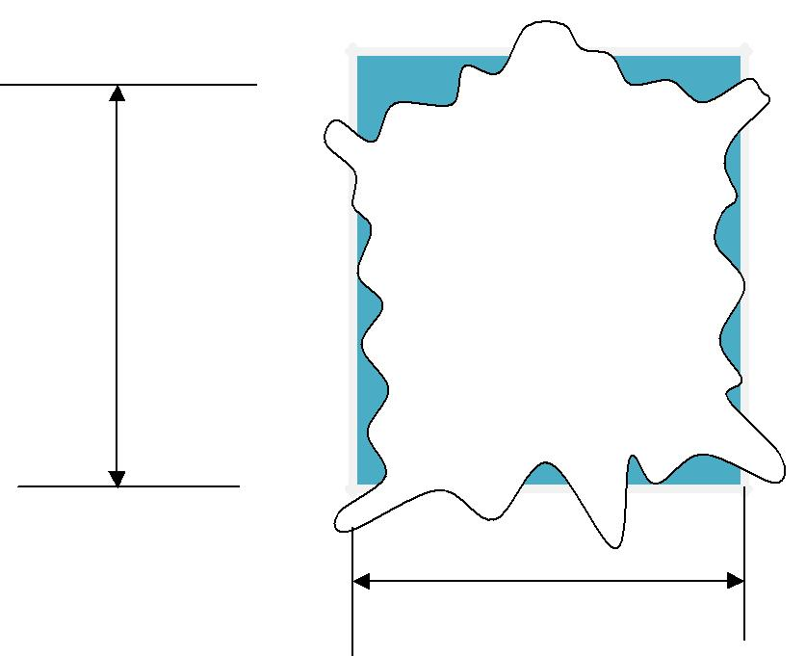

A

B

Thus if (A) were 33 inches and (B) were 27 inches, it would be described as 30 inches square. As skins do not vary very much in the proportion of their length to breadth, the inaccuracy is not of serious importance.
Thickness

9 | P a g e

The thickness of leather is measured with spring loaded caliper gauges. The harder the leather, the more accurate the reading. The contact points of the caliper will sink into or compress a very soft leather, showing a ‘thin’reading, the greater the spring pressure applied or the smaller the area of the contact plates. This can make significant differences when some areas of the skin are softer than others. It is essential therefore that the spring caliper gauge be calibrated regularly against a standard dead-weight gauge with weight and anvil size to international standards. Most light leather thicknesses are measured in millimeters. Sole and heavy leathers can be measured with a sole leather gauge graduated in irons or ounces.
In sorting hides it is significant not only to know the area but also the thickness particularly if this sorting is also to indicate which selections are to be split etc. This can be carried out after unhairing, usually in the wet blue chrome tanned condition. A conveyor fed machine is available which automatically records the area and thickness of the hides as they pass beneath sensing heads. This is known as the photoscan machine. The thickness of raw hides and skins is not uniform and hence it is necessary to preselect those areas of the hide whose thickness measurement is to be recorded, e.g. butt and belly areas. When hides are bought by weight and sold by area to a specified thickness, this system gives a much more accurate that thick or thin or “spready”.

Volume

Volume defines a space occupied by a substance. The volume of a solid rigid material can be calculated by measurement of its dimensions i.e. length, breadth and depth or height and expressed in cubic inches, cubic centimeters. A liquid has no shape as it adopts the shape of the vessel holding it. Measuring vessels are therefore used.

Capacity of pits, paddles, drums, tanks, etc.

The volume of water which various items of tannery plant will hold can be determined by careful measurement of the volume required to fill them to a working float. The volume of square or rectangular pits etc can be calculated in cubic feet or cubic metres, by simple multiplication of length by breadth by depth.
The volume of drums and cylindrical tanks is given by multiplying the length by the circular end area. The cubic capacity in cubic feet or meters = πR²L(where π=22/7 and R=radius of a circular end and L is the length of the cylinder in feet or meters respectively.

10 | P a g e

A special case may arise when a drum is partly to be filled with water, if the length is L, the radius R and the depth of water at the deepest point D, the volume of water is given by Lx4x3x√(2RD-0.608D²). Where paddles have a semi circular cross section, they may be considered as half a drum. It should be noted that 1cubic foot = 0.0283cubic metres = 28.316 litres = 6.23 Imperial gallons. 1 cubic metre = 1000litres.

Specific Gravity

Specific gravity (SG) is a factor used for converting volume into weight or vice versa. Its official definition is as follows;
Specific gravity is the relationship between weight of a certain volume of any substance and the weight of the same volume of water at 4ºC. In the case of water the SG = 1, and so 1cm³ of water weighs 1g, whereas 1cm³ of mimosa extract (SG = 1.2) weighs 1.2g.

Specific Gravity can be measured in 2 ways:

- Weight - By weighing a measured volume of water

- Hydrometer

There are several types of hydrometers in use in tanneries e.g. barkometer, Baume and Twaddel. They are similar in appearance

Temperature

This is measured by the use of Thermometers. At normal atmospheric pressure, centigrade thermometers register 100ºC in boiling water and 0ºC in freezing water.

Heat

It is often desirable in a tannery to calculate the amount of steam or hot water or hot air required to raise the temperature of a given mass of water or wet skins to a require temperature.

Humidity

A given roomful of air can only evaporate, or dry off a certain amount of water. When the air is incapable of taking up any more water vapour at that temperature, it is said to be saturated or to have 100% Relative Humidity (RH). If the air contained no water vapour, so that it was absolutely dry, it would have 0% Relative Humidity.
HIDES AND SKINS AS A MATERIAL FOR LEATHER

Chemical structure of a hides and skins

11 | P a g e

Anatomical structure of a hide or skin can be divided mainly into two principle layers:

- The epidermis or the outer layer –also called the epithelium cuticle.

- The corium or the inner layer –also called dermis, cutis vera, true skin

These two layers, the epidermis and the corium are quite distinct in their structure and function. In bovine animals the living cells in the embryo arrange themselves in three layers (triploblastic). From the uppermost of these layers, (the ectoderm), the epidermis of the skin is formed. The corium is derived from the middle layer or the loosely arranged parts called the mesenchyme of the developing embryo or the mesoderm. Due to their difference in origin, their physical and chemical properties are different. The outer layer (epidermis) consists of epithelial cells. It has no blood vessel of its own but draws nourishment from the blood and nymph of the corium on which it rests. The corium is made up of connective tissues and unlike the epidermis, it is

predominantly fibrous.
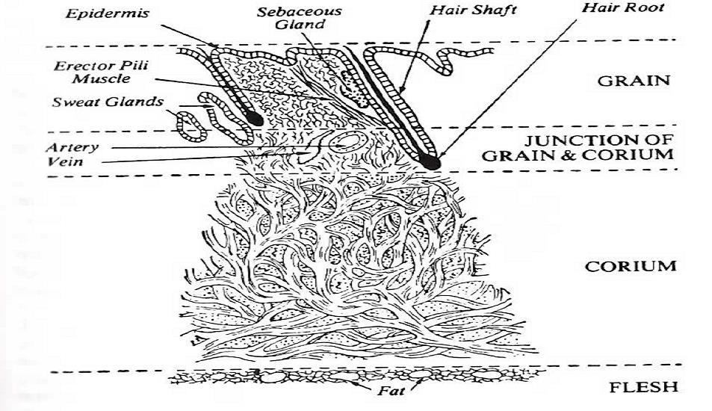

CROSS SECTION OF SKIN

Water (64%) Protein (33%) Fats (2%) Mineral salts (0.5%) Others (pigments) (0.5%)

Note; All animal hides/skins are made up of the above constituents.

Elastin –Yellow fibrous network which has a binding effect on the collagen fibre structure. Its amino acid content is similar to silk and as a result, it has similar properties. Elastin fibrous do not have a tendency to stick together and they do not decompose.

Collagen –The principle structural protein of the skin which is tanned to produce leather. The long protein chains are woven together to produce fibrils; a number of fibrils form a fibre and the fibres are arranged into fibre bundle. Its most important chemical property as far as the tanner is concerned is that the collagen contains both acid and basic amino groups. It is insoluble and does not break down in water unless subjected to heat, bacterial action or strong acids and alkalis.

12 | P a g e

Keratin –The structural protein of hair (and scales in reptiles and fish), all of which has a function as a protective covering. It is insoluble in water but slowly soluble in weak alkalis which is the basis of traditional unhairing process.

Albumen – Soluble non fibrous materials which are largely removed in liming. Failure to remove them will result in the cementing of the fibrous.

Fats –Normally referred to as lipids in broader term for fatty like substances in the skin. They are characterized by their insolubility in some organic solvents. They have to be removed prior to tannage to avoid uneven chemical penetration and fixation.
Mucins and mucoids –Mucous materials associated with fibres.

Mineral salts –Phosphorous in epidermis, copper (skin pigments), silica, arsenic and calcium are present in the skin.

PHYSICAL STRUCTURES OF HIDES AND SKINS.

Cow hides: Forms the major bovine material for tanneries all over the world. In Africa, hides are smaller and usually dried. South African hides are usually dry salted. In China and Indonesia the hides are dried aand liable to insect damage. Indian hides are usually of the humped-backed zebu brahma variety, largely from the Northern states e.g. Bengal, Bihar, Orissa, Upper provinces and Central provinces. They are usually sold raw in in shade dried condition, the best types being assenicated against insect attack, and the rest pasted on the flesh with khari salt and water and dried.

Buffalo: The hides tend to be thicker, badly wrinkled over the shoulder and of a coarser, looser texture than cow hides. They are exported in the dried, paste-dried or vegetable tanned state from India, Pakistan and Indonesia.

Sheep: The widely differing characteristics depend on the breed of which there are many. Their skin vary from about three to twelve square feet each and the amount of wool can weigh twice as much as the skin proper. There are many distinct types including:

- Australian merino which has high grade silky wool which can grow to extreme lengths. It has a weak, very greasy pelt with unsightly rib-like folds on the grain and is of the lowest overall sheepskin quality.

- British breeds ranging from large down land types-which have long wool, very large well-grown skins, good fleshes and grains but heavy grease deposits especially in the

13 | P a g e

back, neck and butt- to the small hill country sheep which have thinner, tighter-textured skins, with fine frains and much less grease.

- New Zealand sheep are basically cross breeds from English strains to give an economic production of prime frozen meat (lamb) for export. The wool is of medium quality and the pelts do not show the major defects of the merino breeds. This highly developed meat industry cares for the skin by product by ensuring that the process of dewooling, liming, bating and pickling for export are controlled to give standard products. The pelts are exported in the pickled condition after careful grading for size, quality and grade.

- Hairsheep. In hot dry countries there are a number of breeds where the fleece quality ranges from coarse hair to wool, generally of less values for textile purposes than pure wool. However, the skin structure is particularly suitable for glove and garment leathers, being strong although thin, of uniform fibre weave, and containing less fat. The grain structure is fine and strong. They are often cased and air dried. Sources are Abysinia, Somalia (e.g. blackheads), Arabia, around the Persian gulf, Turkey (fat tailed types), Brazil (cabrettas) and cross breed from South Africa.

- Dressing sheep skins are those selected from normal abattoir productions to be tanned with the wool on. For this purpose, the wool fineness stapple length and density are very
significant. They may be used for rugs where the stapple length may be over 2inches, or for garments where the wool length may be as low as ^{1/}₂ inch. The wool density and fineness will vary with the characteristics required for the finished product. A thin flexible pelt is desireable. For uniform dyeing of the wool, different breeds should not be mixed.

- Shearlings. When used in a general sense, the term refers to skins from sheep and lambs after the first on the farm. When used in spacifications originating from America and South Africa, the term denotes a selection of skins considered suitable for dressing made from the run of shorn skins.
- Slink lambs refer to unborn lambs, small and with little wool and also to lambs from

South Africa, Afghanistan and Angola lambs killed within hours of birth.

Goatskins: These are tougher and more tightly fibred than sheep, and have a very hard-wearing grain. The supplies come from India, East and West Africa, Abbysina, Aden, South Africa, Southern Europe and Central and South America. Large supplies are also available from the far East. The raw skins are dry salted, wet salted or simply dried and then baled for shipment to

14 | P a g e

tanneries. Mixed qualities and size are obtained from India. Wet blue unhaired goatskins grade for quality and sold on area basis are obtained from India and Pakistan. East Africans often offer grain damaged (due to disease and drying faults) goatskins and the majority are used for the productions of suede. These are usually suspension dried. Nigeria offers one of the finest skin of the red goat ‘sokoto’‘Kanos’too are popular, as they are uniform in size and shape and they are spared the many hazards of the nomad herds. These skins are used for all types of kid upper leather.

Pig skins: These have a distictive grain structure, the hair penetrating through the usable grain structure leaving holes in itof a pattern peculiar to the pig. The main types include the ‘wild boar’ (or peccary), a leaner and smaller variety giving a tough grained leather for gloves and garments. The English and USA pigs are larger and much fatter and the number of fat cells in the corium may so distort the structures as to render much of it useless for leather making. Main supplies therefore are from China, USSR, Middle Europe, Japan and USA but with adoption of flaying techniques, suppliers may increase.

Horse hides: These are often of no uniform quality compared to that expected from hides and skins from cattle. This is because cattle are slaughtered for human consumption which applies to a much lesser degree to horses. The back portion of the hide, from the rump, contains a much thicker, less porous, and tougher area known as the crup. This is usually cut and dressed separately often for cordovan leather. The fore part also known as the horse front is used for heavy gloving and shoe upper leather. Quality supply is from France, Belgium,Holland, Scandinavia and the United Kingdom.

Reptile skins: Usually sun dried although shade drying is preferred, the supply comes majorly from India (Bengal lizard, Ring lizard, Aer and Churi) and Indonesia (Diamond python and Karungs). There are also from Africa the Large grain and the Fine grain African lizards. In place of the hair and epidermis of mammalian skins, reptiles have a keratinous layer of scales, which is removed in the limeyard. The weave of the fibre is different for those cold blooded creatures, being much more horizontal and dense, so that the skin tends to be very tough, thin and less soft or supple than mammalian skins.

Crocodile skins: These are obtained from Africa and the Far East (usually Singapore). Large scaled crocodiles come from Far East while small scaled comes from Africa. Small scaled is preferred. The skins are flayed in two ways, that is ‘belly’or ‘horn back’. All accessible areas of

15 | P a g e

the world where crocodiles exist produce raw skins in fairly small quantities. The skins command a high price and are made into very expensive leathers.

Note; Since the introduction in 1973 of the Convention on International Trade in endangered species of Wild Flora and Fauna, commercial trade in crocodiles, and several species of reptile and their derivatives have been limited or banned by many countries.

CURING OF HIDES AND SKINS

Hides and skins can be processed within hours of slaughter when a processing plant is near a large abattoir, but many a times there might not be enough stock for processing. This calls for need for preservation. During the period between flaying and any other processing e.g. transportation or storage, damage to the hide may occur. Some of these damages are, tears, cuts, hook marks, contamination with dirt, insect or rodent attack, but the most common and immediate danger is by putrefaction which causes the desirable protein fibre structure to be degraded, or in extreme cases, to become rendered completely water soluble (gelatinization)

Putrefaction is caused by the digestive action on the hide of micro-organisms called bacteria. Putrefaction only occurs in the presence of free water and the presence of dissolved substances may inhibit it, notably high quantities of salts, acids or alkalis, bactericides or other toxic chemicals. Simple removal of water by drying or the use of such chemicals are obvious methods of preservation.

Major curing methods and their effects

Curing is a term used in the preservation of hides and skins. The aim is to preserve the hide or skin against putrefaction damage. This is divided into short term preservation for 3 –4 days or long term preservation.

Freezing Techniques

As used in the preservation of carcass meat are relatively expensive and also involve problems in transport and subsequent de-freezing in the tannery.

Freeze drying is a technique whereby the hides are subjected to low temperatures and low pressures (i.e. vacuum). Under these condition the water in them sublimes, i.e. goes direct from the solid ice phase to gas phase. It is considered too expensive for use.

16 | P a g e

Rapid chilling removes the body heat of the skin quickly and thus the rate of autolytic or putrefaction changes. The simple method is by hosing, dipping, etc in cold water e.g. 3ºC. A plentiful supply is necessary otherwise the chilling will be inadequate.

A current practice is to stuck the freshly flayed hides, flesh side out, in small piles not more than 5 or 6 deep on pallet trolleys, and expose them overnight in a chilling tunnel to an air blast at 1⁰C so that they rapidly reach a temperature of 2-3⁰C. They may be stored satisfactorily for two weeks in a cold store.

A plant is on the market which can reduce the temperature of flayed sheepskins 15⁰C in 30 seconds and salt is then applied. Simple chemical methods which have been advocated are:

- To spray the flesh side with a 20% solution of zinc chloride or drum in a 50% float containing 0.5% zinc chloride and 0.05% sodium pentachlorphenate. This may cause problems in subsequent soaking or effluent disposal.
- Drum the hides in a 20%- 30% float containing 1% sodium sulphite and 1% acetic acid for 10-30 minutes, this should give an acidity of 4.5-4.7 pH. Too much acidity liberates noxious sulphur dioxide gas whilst too little gas gives inadequate cure. Basically, the process depends on an appropriate level of sulphurous acid (sulphur dioxide dissolved in water) and the success of the method depends on the control of this to avoid the production of excessive amounts of noxious poisonous gas. Good preservation for some weeks can be achieved.

- Sodium chlorite has been suggested, either as a spray of a 20% solution or by drumming in a 0.3% solution. However, there are hazards in handling this dangerous oxidizing agent.

- Boric acid is non-toxic and a safe chemical to handle, drumming in a saturated solution can give a satisfactory cure owing to its mild antiseptic action. It is expensive due to the

large amounts required and is not practical unless the solution can be re-used by some re-cycling technique.

Wet-salting

The cold, flayed hide is spread out, flesh side up, on a concrete floor and well sprinkled with salt (sodium chloride). Coarse or round-grained salt is preferred to fine salt, as the former spreads better, whilst the latter forms patchy, wet cakes. A second hide is placed on the first one and also sprinkled with salt. This is repeated until stacks 5-8 feet high are formed, the top hide being well overlaid with salt. The stack is left for days, when the salt dissolves in the moisture in the skin

17 | P a g e

and the brine permeates the pile. The amount of salt used should be 25-30% of the raw hide weight. Less salt is used in the case of sheep and goat but in all the cases the salt content of the damp salted hide or skin (less wool or hair) should be of the order of 15-25%. During salt piling, the skins drain, lose some moisture, and therefore lose some weight. In the case of hides this may amount to 10% of the drained flayed weight. Drained salted hides contain about 50% of water. Clean mineral salt should be used. Because halophilic bacteria are acclimatized to living in salt solutions and are commonly present in marine salt (from sea water evaporation) or in dirty salt, re-use of salt and the use of marine salt are dangerous.

Brining

Brining is a more efficient method, practiced in the big American abattoirs. The hides are cleaned by hosing with water and are then hung in pits or run in large paddles in a very strong salt solution (brine) containing about 30 lb salt to every 10 gallons of cold water (210⁰ BK).

Dry-salting

The flayed skin is salted by either, or both, of the above methods and then is hung up to dry. This reduces the weight and the cost of transport, but care must be taken that:

- Drying is carried out gradually and evenly. If the skin gets too hot it may partly gelatinize, or turn to glue, giving it a horny feel. When it is put in water these parts dissolve away leaving holes in the skin.

- When the skin has to be tanned, it must be soaked in water until it has taken up as much water as it had on flaying. Dry-salted hides obviously require longer and more careful soaking than wet-salted hides.
Drying

As bacteria must have a certain amount of free water or moisture if they are to attack the hide, putrefaction can be stopped by removal of water so that the hide contains only 10-14% moisture. Their activity then ceases, and some types are killed, whilst others dry up into a spore form, in which they can remain a long time until there is enough water for them to be active again.
Curing by drying requires care, especially with thick hides because:

- If drying is too slow, (as in a cold, wet climate), putrefaction may occur before the moisture content is low enough to stop bacterial action;
- If drying is too fast and the temperature is too high, part of the wet skin will start to gelatinize to a glue-like material. This makes the skin hard and brittle and prevents drying of the inner layers. It is difficult to see this fault in dried hides until they are soaked back

18 | P a g e

in water, when holes appear or the smooth grain is lost or has a blistered appearance, owing to the gelatinized part of the skin dissolving in the water.

Drying is practiced in countries with hot, dry climates, such as India, Africa and South America, where the latter danger is real. The hides may be:

Ground-dried: the hides are simply spread out on the ground, sometimes on a bed of twigs or stones. This may be dangerous owing to poor ventilation of the ground side and high temperature of the exposed side, plus contamination with dirt.

Sun-dried: the hides are hung or laid over poles, ropes or wire in the sun. This gives better ventilation and quicker drying, but may result in heat damage and pole or rope marks, showing as hard creases down the hide.

Frame-dried: The hides are loosely strained out of frames, which are arranged so that they do not receive the direct rays of the mid-day sun. This gives less danger of heat damage and a better, flatter shape. The hide shrinks on drying and tightens up in the frame, and if it is put in too tightly, over-straining or stretching may cause weakness and thinness. Frame-dried hides are of better shape, more uniformly dried and less liable to putrefaction or heat blisters than ground dried or sun dried.
Shade-dried: The hides are dried in an open-sided, covered shade, designed to keep off the direct heat of the sun but to allow good ventilation. It also protects the skins against occasional rainfall.

Dried hides and skins are susceptible to insect attack (e.g. beetles, larvae and maggots). A common method of prevention is either to dip or to spray the hides in a solution of white arsenic and caustic soda (approximately one-fifth percent of the weight of water). This liquor is poisonous. Other methods use naphthalene, sodium silicofluoride, D.D.T., or benzene hexachloride, as sprays, dips or dusting powder.

Pickling

This method is nearly always used for hides or skins after they have been unhaired or dewoolled, limed and fleshed, particularly in the case of sheepskins, where the more valuable wool is removed and the remaining skin is then pickled and drained ready for marketing. In the case of woolled skins the removal of the wool is often known as fellmongering.

Various types of putrefaction and their prevention.

Putrefaction is the damage to the hide/skin material as a result of bacterial which promptly starts once the animal is dead, especially on the exposed flesh side of the flayed hide/skin unless it is
19 | P a g e

properly cured. Bacteria are living organisms and in this case, they secrete their digestive juices on the hide. The active ingredients being enzyme, the living bacteria cell then re-absorbs such of the digested substrate (on the hide) as it requires it for nourishment, leaving the enzyme still on the hide. Thus all the bacteria may be killed or removed, but the enzyme digestion system may still function and putrefaction continues.

Most bacteria are sensitive to their habitat and if conditions are unfavourable they may be killed or go into spore form until the conditions become suitable. Under ideal conditions they can multiply very rapidly. Chemicals which kill or consequently prevent any subsequent breeding of the bacteria are known as bactericides whilst those that stop or inhibit their active life are known as bacteriostats. In some cases the already deposited enzyme could continue to putrefy while the bacterium is dead or inactive.

There are many types of putrefying bacteria which can be identified by;

- their shape,

- breeding habits,

- the nutrient material they live on,

- the conditions of;

  - temperature of their surroundings

  - pH of their surroundings

  - moisture content of their surroundings and

  - the chemical nature of their surroundings

It must be appreciated that adverse conditions which inhibit one bacteria may be acceptable to another type. Some bacteria can develop immunity to conditions which were originally adverse. The presence of other species of bacteria or moulds may itself constitute other diverse conditions for other types. Putrefaction only occurs in the presence of free water and the presence of dissolved substances may inhibit it, notably high quantities of salts, acids or alkalis, bactericides or other toxic chemicals. Simple removal of water by drying or the use of such chemicals are obvious methods of preservation.

BEAMHOUSE PROCESSING

“Leather is made or marred in the beamhouse”

Is the leather made in the beamhouse or the statement so great an over-simplification as to lack any credibility? As the first stage of the process, it is the base on which all other processing is built. It is a process principally of purification. When it is complemented by bating, it isolates the leather-making protein chemically and modifies the structure of the hide or skin physically.

20 | P a g e

It is a stage of leather processing which, because of its nature, receives limited day to day technical attention. It is at best dirty and unpleasant to work in a lime yard. It is difficult to relate problems encountered in soaking and liming to the finished leather and the enormous range of processes which have been completed to convert one to the other.

The day-to-day assessment of the performance of the beamhouse systems is difficult. Those measurements and objective observations which can be made are either inconclusive in terms of the finished product or are excessively complicated. In terms of day-to-day we are able to look at two aspects:
- The condition of the soaked or limed or hide

- The nature of the waste sock or lime liquor.

The truly objective test of taking raw hides through the process to finished leather is unwieldy and difficult to control. However, properly used and monitored, these techniques are extremely productive.

Actual processing systems vary widely according to local practices, raw materials, facilities available and the finished product. However, it is possible to organize the information for beamhouse processing, as it is for most processing in the industry, in the following way:

- Definition

- Objectives

- Process variables

- Practice

- Theoretical background

- Process control

We shall be able to look at beamhouse processing in this way for each individual section and then try to relate the different sections to each other, to subsequent processes and finally to finished leather. The background to this review will be an orthodox drum liming system, though some important variations will be identified and described.

- SOAKING

  - Definition

Soaking is normally the first chemically based process that takes place in the tannery. It is designed to reverse the curing process and to begin the process of purification, prior to tanning.

21 | P a g e

- Objectives

  - To reverse the curing process and to return the hide as near to its raw state as possible.

  - To remove chemicals which have been added during curing.

  - To rehydrate the hide evenly.

  - To remove extraneous matter such as blood, dirt and dung.

  - To begin removal of partially degrading protein.

The relative importance of the variable obviously varies from raw material to raw material. Dry hides for example, require considerable attention in order to rehydrate the satisfactorily. Dirty, wet salted hides need more work in order to obtain the degree of cleanliness required.

- Process variables

In all cases, the soaking process has to be designed to bring the hides into intimate contact with the required volume of water in order to achieve the stated objectives. The process variables are as always, a matter of compromise.

- Volume of water

The ratio of water to goods varies considerably with local practice and the type of raw materials employed. If the ratio is too low, i.e. not enough water, the following problems could occur:-

  - A rapid increase in soluble material in the water, inhibiting the further diffusion of the raw materials remaining in the hides,
  - Physical opening up and movement of the hide restricted,

  - Poor distribution of chemicals,

  - Poor chemical action.

However, if the ratio is too high, i.e. too much water

  - Production will be limited,

  - The salt will be dilute to remove globular protein,

  - Chemicals will be too dilute,

  - Energy costs will be increased.

- Temperature

22 | P a g e

An increase in temperature will increase the rate of rehydration and the rate of “cleansing”. There is, however, a limit to the temperature which can be used, and that is the shrinkage temperature of the skin. Elevated temperatures will also encourage the activity of bacteria. This aspect increases the significance when soaking times are extended. Therefore, the achievement of the objectives by raising temperature has to be tampered by caution, to avoid damaging the hide by excessive temperature or encouraging bacterial action.

1.3.3 Time

Increasing the length of the soaking process will assist in achieving the objectives but it has several obvious disadvantages:-

- Extending times can reduce productive capacity or time available for subsequent processing.
- Extended soaking periods can increase the possibility of bacterial damage, especially when allied to elevated temperatures.

- In terms of the “cleaning”objective, the “dirt”in the hides and the “dirt”in the liquor will reach equilibrium at some stage, and there is no benefit in extending the soak time beyond this without changing the float.

1.3.4 Mechanical Action

An increase in the level of mechanical action will increase the rate of “cleaning”and rehydration but:
- An increase in mechanical action will increase the development of frictional heat and therefore the temperature inside the process vessel will rise, producing first of all favourable conditions for bacterial growth and ultimately the possibility of heat damage;
- Excessive mechanical action will increase the possibility of abrading the grain of the skins and over flexing.

It is important to remember that there are a number of factors which will change the level of mechanical action. Some of these are listed below, but a detailed study is beyond the scope of this paper:-

- Drum speed

- Drum geometry

- Pegs or shelves and their distribution

23 | P a g e

  - Float levels

- Chemical additions

The chemicals which are commonly added to soak liquors can be divided into four distinct groups:-
- Wetting agents- a number of proprietary materials are available; particularly favoured is the non-ionic group, which has no substantivity for the skin. Their function is threefold:-

  - To increase the rate of rehydration. This, of course, is particularly important when the raw material is difficult to wet, e.g. dry hides;
  - To increase the rate of cleaning. Their surface active effects will improve the rate of “debris”removal;

  - To begin to emulsify the fats in the hide, this is to be completed in liming and degreasing.
- Alkalis

Alkaline materials are often used in soak liquors, principally to improve the rate of rehydration. This is achieved because the skins swell, i.e. take up water when the pH is increased, i.e. made more alkaline. Sodium carbonate, sodium hydroxide and sodium sulphide are the most frequent additives.

c) Enzymes

Enzymes are catalysts, i.e. materials which assist in a chemical reaction but are not themselves directly involved. They are specific; they act only on one group of materials, e.g. soluble proteins, structural proteins, fats, etc. in soaking, they can be utilized to perform the same functions as wetting agents. It should be borne in mind that they operate best under a narrow range of conditions, particularly temperature and pH.

d) Bacteriocides/Bacteriostats

particularly when the soaking times are extended, it may be necessary to make use of materials which will kill or inhibit the growth of bacteria.

The first three groups of chemicals then can be considered as accelerators- we may be able to cut down on a more expensive commodity (e.g. time) or to ease the demands on production facilities (e.g. drums) –while the fourth group is a protection against possible damage.

- The Practice

24 | P a g e

The practice of soaking varies widely from tannery to tannery. The major consideration when designing a soaking process is the cure to which the hides or skins have been subjected. It is not possible to specify processes here for every type of raw material, but the main parameters for the major cures can be discussed.

1.4.1 Wet-salted or brined hides and skins 1.4.1.1 Water

The quantity of water based on wet-salted weight would normally be between 300-500%, with one change of float.

1.4.1.2 Temperature

The temperature employed in this operation is limited by the shrinkage temperature of the skins, in the past would normally be carried out cold. However, as in most stages of leather processing, one of this washing is to adjust the temperature for the immediately-subsequent process. There has been a trend recently towards warm limes and therefore soaking temperatures have been increased and are usually in the range of 25 –28ºC

1.4.1.3 Time

For wet salted or brined hides, extended times are unnecessary; practice varies, but is usually between 3 and 6 hours, often a one-hour dirt soak followed by a four hour main soak.

1.4.1.4 Mechanical action

In order to minimize abrasion and over-flexing of the hides or skins, mechanical action is kept to a minimum usually by keeping drum speeds down to 1-3 r.p.m.

1.4.1.5 Chemical additions

Only two groups of chemicals are used, wetting agents and soaking enzymes, simply to achieve an acceptable soak within the time available. Because of the short time involved bactericides are not required.
1.4.2 Dry and dry salted Hides and Skins 1.4.2.1 Water

The quantity of water, based on dry weight, would normally be 600-900% with up to five changes of float

1.4.2.2 Temperature

Elevated temperatures have to be used carefully because they will tend to encourage bacterial action, an important consideration when extended times are involved.
1.4.2.3 Time

25 | P a g e

The range of times is as follows for hides;

Dry salted hides 24 –48 hours

Dry hides 48 –72 hours

Skins obviously require shorter times

1.4.2.4 Mechanical Action

Mechanical action is an important factor. Often the initial stages of the soak are carried out it static baths. Too early movement before hides have taken up sufficient water can cause cracking of the hard dry skins. For this reason, pit soaking and indeed liming is very relevant to the soaking of dried hides and skins. However, in the later stages, rehydration is often improved by high levels of mechanical action, including limited periods of dry drumming to flex and open up the hides or skins.

1.4.2.5 Chemicals

The whole range of chemicals has to be used in order to achieve acceptable results, particularly for dried skins. It should be remembered that bactericides have to be used in order to avoid strong possibility of bacterial action.

1.5 Background

Soaking then is accomplished by immersing the hides in water which may contain various additives. Temperature and mechanical action are used as a tool to increase the rate of soaking, rehydration and cleaning. The water will dissolve the curing salt and reduce the concentration of salt in the hide. This in itself will cause water to be taken up by the hide and rehydration will occur. Along with rehydration, soaking accomplishes the first stage of the “purification”process prior to tannage, when soluble proteins are dispersed.

1.6 Process control

Day to day works control of soaking in order to achieve consistent results is necessary. We have two aspects to consider:-

- The condition of the soaked hide or skin –In the case of soaking, this would involve a subjective judgment on cleaning and rehydration.

- The “nature”of the waste soak liquor –Measuring the salt concentration of the liquor can be used as a works control procedure, as can the determination of the level of soluble nitrogen. A subjective judgment of the “dirtiness”is also important.

26 | P a g e

The hides or skins are now sufficiently rehydrated and cleaned to go forward to liming. It is a considerable advantage for the hides to be fleshed at this stage, as this operation will accelerate the liming process and produce much more uniform results.

- LIMING

- Definition

Liming is normally the second chemically based operation that takes place in the tannery. It is designed to further purify the raw material and isolate the material from which leather is to be made
- Purposes

  - To remove the hair or wool from the skin

  - To remove the epidermis

  - To swell and plump the collagen fibres and fibrils

  - To modify the non-structural proteins so that they can easily be removed (particularly in bating

  - To destroy nerves, blood vessels and muscles

  - To weaken membrane surrounding the fat cells and to facilitate degreasing

  - To facilitate fleshing by swelling the flesh

  - To break down restrictive structures which surround the fibre bundles

  - To modify the collagen molecules (loss of some amide group and some crosslinks)

All of these objectives are equally important and have to be achieved. Obviously where the hair or wool have to be retained, a different approach has to be used to achieve the remaining objectives.

2.3 Process variables

The design of liming systems is both product and raw material dependant. The liming objectives stated above have to be achieved, and considerable variations in the characteristics can be accomplished using the process variables.

2.3.1 Float length

The length of the float has of course a major effect on chemical concentrations: the longer the float, the lower the concentration of a given addition of chemicals. The level of added water can also be used to control the degree of swelling, so that high concentrations of chemicals can be used to produce rapid unhairing, but the water
27 | P a g e

present is not sufficient to give an acceptably high swelling. The so called “drum painting” process uses this phenomenon to good effect. The amount of water employed has an effect on the level of mechanical action produced. This will be discussed later. Another factor to be considered is that there is sufficient water to prevent folding and creasing.

2.3.2 Temperature

Temperature effects in liming are currently receiving considerable attention. The upper limit of temperature is of course limited to the pelt’s shrinkage temperature and a “safe”margin must be allowed.

The plumping effect of liquors containing lime is reduced by increasing temperatures accompanied by a reduction in the solubility of lime. Elevated temperatures will accelerate the rate of hair destruction.

In drum liming, temperatures of 28-30ºC are now not uncommon but care must be taken to avoid heat damage. Above all other considerations, it has to be remembered that temperature has a substantial effect and that, as in other areas of processing, consistent conditions are paramount.

2.3.3 Lime

The liming process is time-dependent. In modern drum liming processes, unhairing is completed very rapidly, within four hours, but the other objectives take longer. Usually a 24-48 hour system is employed. The high alkalinity of the system prevents any bacterial growth, and therefore the system is designed around the production facility available.

2.3.4 Mechanical Action

During the liming process, the hides are in a swollen condition and are therefore exceedingly sensitive to mechanical damage caused by abrasion, and flexing of the plump structure. Mechanical action is therefore kept to a minimum, sufficient only to maintain adequate distribution of the chemicals. A wide bodied drum running at 1-2 r. p. m. is normally employed and, often, intermittent running and reversing gives an added advantage. The newer development of cement mixer type processors is now in common usage, offering significant advantages in control of mechanical action, chemical addition, loading and unloading

28 | P a g e

2.3.5 Chemical Additions

Four major chemicals are used to achieve the stated objectives. They can be divided into chemicals which assist and accelerate unhairing and those which complete the swelling and opening up function.
1) Unhairing

a) Sodium Sulphide

Sodium sulphide reacts with water to produce sodium hydrosulphide and sodium hydroxide.

Na₂S + H₂O ® NaSH + NaOH

It is the hydrosulphide product which produces the unhairing effect and the sodium hydroxide, a very strong alkali, raises the pH of the system and increases plumping.

b) Sodium hydrosulphide

This material is less alkaline than sodium sulphide, and is therefore used to increase the unhairing properties of the liquor without increasing the plumping. However it should be noted that it does increase the alkalinity of lime containing liquor.

Ca(OH)₂ + 2Na(SH)₂ ® Ca(SH)₂ + 2NaOH c) Amines

Amines in the form of dimethylamine or dimethylamine sulphate have been recommended as a partial replacement for sodium sulphide. These materials buffer the system reducing the plumping effect.
2) Plumping a) Lime
The most commonly used form is hydrated or slaked lime CaO + H₂O ® Ca(OH)₂

Lime is only sparingly soluble in water, and therefore provides a reserve of alkalinity maintaining the pH at about 12.5
b) Caustic soda (Sodium hydroxide)

A strong alkali which can be added separately to increase the pH and therefore plumping – it is of course normally added with sodium hydrosulphide dissolved in water. There are a number of minor chemicals which are occasionally used in liming to modify the performance, mainly to reduce the plumping power of the liquor, e.g. glucose and salt (see 2.3.6)

29 | P a g e

2.3.6 Condition of the soaked pelt

The soaked hide will carry forward into liming 60% of its weight as soak liquor. The concentration of materials in that soak liquor therefore has a major effect. Degraded proteins carried forward may increase the unhairing properties but they will also lower the degree of plumping. Salt can also be carried forward in varying quantities. Above 3% it will inhibit plumping, but below 3% plumping will be increased. For consistency of results, therefore, consistency in operating practices is once again of paramount importance. The quality of rehydration obtained in soaking is another factor influencing the performance of the liming process.

2.4 Practice

Liming practice varies substantially from raw material to raw material and tannery to tannery. The degree of soaking will influence process design enormously. Whether the hair is to be saved or destroyed is a factor of major importance.

- Hair saving

  - Painting systems

Hair or wool removal by painting is a commonly used method, especially when the hair or wool is of high value. The skins are painted on the flesh side with a sodium sulphide solution thickened with lime (or kaolin). After e relatively short period, the wool can be “pulled”and should be found to be uncontaminated. The dewoolled skins would then be subjected to liming, to achieve the other stated objectives.

2.4.1.2 Drum, pit or paddle hair saving

In this type of hair saving process, the hides are treated with low sulphide concentrations which attack the hair only at the root (immature keratin). The hair can then be removed by hand or machine. Whilst the market for hair has receded, this process has a distinct technical advantage in that the hair is removed completely from the follicle and the grain surface is therefore cleaner.

2.4.2 Hair destruction

Here the hides are subjected to high sulphide concentrations, high enough to attack the cornified keratin of the hair shaft. The hair is destroyed rapidly, but the process has the disadvantage of leaving the base of the hair in the follicle, producing a dirty looking grain.

30 | P a g e

2.4.3 It is impossible to produce a picture of the range of variations in liming practice, but the following review on the processing of soaked hides (percentages based on wet salted weight) is indicative :-

- Float

The quantity of water used would normally be 200-400%. However there are a number of processes which start with float as low as 30%, water being added through the liming process to increase the level of plumping (see 2.3.1).
- Temperature

Temperatures of 25 –28⁰C are now common.

- Time

Liming times vary (standard drum liming) from 18 to 48 hours, usually designed to fit in with working practices and production facilities.

- Mechanical action

Mechanical action has to be kept to a minimum as the pelt is in an extremely sensitive condition. Normally 1-2 r.p.m. in a wide bodied drum for only 5 minutes per hour is sufficient.
- Chemical additions

  - A typical total chemical addition for wet salted hides in a drum liming would

be as follows

a). Sodium sulphide/sulphidrate 2_{1/2}–3%. The larger the proportion of sulphidrate the lower the degree of plumping.
b). Lime 2-3%

Traditionally an excess of lime, about 5%, was added. Because of the limited solubility of the lime, this is not necessary and in fact creates problems in deliming.

    - In a pit hair saving system, the concentration of the chemicals would be as follows:-
a). Sodium sulphide 0.25% b). Lime 2%

2.4.3.5.3 A typical paint formulation would be:-125g sodium sulphide (62% Na₂S)

31 | P a g e

125g hydrated lime

125g kaolin

600g water

2.5 Background

Liming is biochemically complicated. However, effects of liming on the pelt can be divided into four major areas:-

2.5.1 The Effect on the Hair

Lime slowly hydrolyses proteins, breaking them down gradually into smaller and smaller groups. Keratin, the protein of the hair, can be changed chemically by treatment with reducing agents such as sodium hydrosulphide. The resultant “reduced” keratin is more susceptible hydrolysis and, in this “reduced”condition, is more soluble in alkali than is collagen. Therefore the use of alkali and a reducing agent results in a breaking down and solubilisation of the hair without damage to the leather making protein, collagen.

2.5.2 The Effect on Interfibrillary Protein

Removal of non-structural interfibrillary protein began in soaking and is continued in liming. If this non-structural protein is allowed to remain in the skin, it will cement the fibre structure together to produce hard, brittle leather.
There are other proteins in the skin which require modification and ultimate removal (perhaps in bating) in order to open up fibre structure.

2.5.3 The Effect on Natural Fats

There are two main groups of fats in hide:-

a). Physiological fats –necessary for the maintenance of body temperatures and hair lubrication.
b). Triglicerides

The former are relatively easy to remove, the latter are more difficult. The alkaline treatment of swelling has a substantial effect on these fats, enhanced by increasing the alkalinity and temperature.

2.5.4 The Swelling Effect

Hide and skins swell in alkali media (also in acid media). The swelling of the skin is a physical and chemical effect. As the skin physically “plumps”as it takes on water, so some of the chemical bonds are broken, making more reactive groups available. So the

32 | P a g e

longer the liming, the more opening up takes place and the more “reactive”the protein becomes.

2.6 Process Control

It is necessary to establish consistent limeyard practices, and day-to-day control procedures are therefore essential, even though the procedures are largely subjective. We can look at liming in three ways:-
- Evaluation of the Limed Pelt a). Subjective.

A general inspection of skins at all stages if the processing produces significant results. In liming, the hair removal and plumping can be compared with previous performance

b). Microscopic Evaluation

If a cross section of limed pelt is placed under a microscope, the effects of liming can be evaluated more accurately and photographs can produce a permanent record. Plumping, unhairing, scud removal and opening up can all be seen more clearly.

- Analysis of the Waste Lime Liquor

- pH or alkalinity –alkalinity of the waste liquor will give an indication of its plumping power.

- Sodium sulphide – The sulphide content will indicate the unhairing power of the liquor.
- Salt –The salt content (and pH) will indicate the effectiveness of the soaking process. Recording the above levels will produce a picture of the consistency of the liming process, especially when it is related to the evaluation of the limed pelt and the finished leather.

2.6.3 Process Surveys

Monitoring the performance of liming in relation to the finished leather produced is the only true objective test.

Beamhouse processing is part of an integrated system of purification, designed to isolate the leather making protein. It is, indeed, the most important part of leather production. It is also the most unpleasant aspect of leather production. The pre-tanning operations employ complex principles of bio-chemistry and are the most difficult part of the whole tanning process to understand.

33 | P a g e

3.0 DELIMING

When hides and skins have been unhaired, fleshed or split, they are in a swollen and plumped condition and are full of lime. The caustic alkali or the lime in the pelt is present in two ways:-

  - Partly as free calcium hydroxide due to capillary binding

  - Partly combined chemically with the acid groups of the collagen due to salt like binding. Before the pelt can be satisfactorily tanned to produce leather, it is necessary to free them from the lime and to reduce its swelling to the extent required for different tannages. Lime content in the pelt may vary from 0.5 –2% on pelt weight.

For effective bating and cleaning of the skin a slightly alkaline pH is desired. The deliming process, therefore, must be one that will solubilize the absorbed calcium hydroxide and bring the skin to the desired pH. Apart from washing free lime with water, additional acid is necessary to bring the pH down to the desired level because of acid base binding capacity of the protein. Calcium has good solubility in ammonium salts of sulfate or chloride. The natural buffering pH of ammonium sulfate is 5, but in the presence of calcium hydroxide is between 7 and 8. The lime is gradually removed from the skin by diffusion and the swelling effects on the hide during this operation are kept at a minimum. This is also the pH range of maximum enzymatic action during bating. The purpose of deliming operation is to bring a bout the pH changes gently and without damaging the skin. During deliming the temperature is usually raise gradually by using hot water at 100ºF, higher temperatures must be avoided to prevent damage to tender protein fibres

- BATING

In the process of bating the ultimate goal is to make pelt pliable and prepare them for the tanning process by treating the skin substance with proteolytic enzymes so as to obtain desired grain appearance in the finished leather. Bating also serves to impart softness, stretch, and flexibility to the leather, while at the same time providing the basis for a clean, smooth grain by loosening scud consisting of hair roots, pigment materials and grease. It also eliminates all traces of the firm, plumped, and swollen state of the pelt induced by the alkaline unhairing liquors by bringing the skin into a soft, fallen condition. Today bating is employed mainly in tanning light leathers, such as those used in bookbinding, where drape, flexibility, and softness of handle are of primary importance.

In the bating process, proteases are used to remove scud and unwanted proteins. The process also deswells swollen pelts. The result of bating with the use of enzymes is a clean, smooth and soft

34 | P a g e

pelt surface. Bating with enzymes achieves the best possible quality of leather and cannot be substituted by chemicals.

In the past, various other methods of bating were used which include using dog, pigeon or hen manure! These methods were not favorable because of the unpleasant odour, unreliability and length of time. The use of enzymes have really improved the process of bating.

The origin of bating is somewhat obscure but probably dates back to the time when liming was not a common practice. It may have been originated by a tanner who noticed that skins badly soiled with dung often produced a softer, stretchier, silkier leather.
As recently as the early years of the present century, the process of bating consisted of immersing the delimed skins in water at a temperature of 35-40°C., and then adding a liquid paste of pigeon or hen dung. The skins were run in this liquor until they acquired a particularly soft, flaccid and silky handle. The finished leather was found to have a very smooth, clean flat, flexible grain and was very soft and stretchy. Considerable variations in time, temperature and quantities were used for various types of leather. The effect of bating was produced by enzymes, which, under appropriate conditions of temperature and pH, are capable of dissolving and digesting some of the protein constituents of the skin. In a properly controlled process they are given only sufficient time for further removal of undesirable interfibrillary proteins, or to modify or weaken those fiber structures which, by binding the collagen fibers tightly together, would cause the grain to be wrinkled and the resultant leather to have no stretch.

Today bating is accomplished by the use of enzymes extracted from animal tissue, e.g., the pancreas of swine or sheep, or from microorganisms such as molds and bacteria, called respectively pancreatic and bacterial bates.

Bating is a further step in the purification of the hide prior to tanning. The practical bating process takes place in a warm bath near pH 7 to 8. The presence of calcium salts is helpful in the activation of most bating enzymes, and deliming adjusts the pH for best enzyme action. The unwanted components consist of some of the protein degradation products, epidermis, hair and scud on the surface of the skin and in the hair follicle and pores.

Degreasing

In the process of degreasing, fats and grease are removed with the use of lipases, detergents or solvents. Fats are removed from the interfibrillary space to allow for the even penetration of various tanning materials and dyes. Degreasing helps make leather soft and pliable when used for other purposes. Enzymatic degreasing is a better way of carrying out degreasing than the use

35 | P a g e

of solvents and detergents. Lipases are much safer and less toxic to workers and the environment. Furthermore, lipases allow for a more uniform colour, cleaner appearance, improve production of waterproof leather, and do not cause dryness in the leather.

5. PICKLING

Pickling refers to the treatment of the hide with salt and acid to bring the skin to the desired pH for either preservation or tanning. At the end of pickling operation, the skin is theoretically a purified network of the hide protein. The pH desires will depend upon the tannage to be used and time between bating and start of tanning. Provided a proper quantity of salt is used to control the swelling, the pure hide protein or unhaired skin can be brought to a very low pH (2.0 or lower) without having a significant breakdown of the skin due to acid hydrolysis. It is customary to maintain the salt concentration at approximately 5% sodium chloride (solution basis), but salt concentrations as low as 3% may be desired for some particular tannage
Once bating is complete, the hides and skins are treated with a mixture of common (table) salt and sulfuric acid, in case a mineral tanning is to be done. This is done to bring down the pH of collagen to a very low level so as to facilitate the penetration of mineral tanning agent into the substance. This process is known as pickling. The common salt (sodium chloride) penetrates the hide twice as fast as the acid and checks the ill effect of sudden drop of pH.

Deliming and bating leaves the hides in a slightly alkaline state, but tanning requires acidic conditions. Therefore, the hides are pretreated with sulfuric acid and formic acid prior to tanning in a process called pickling. Without this conditioning, the tanning agents would quickly become fixed at the surface of the hide while its inner layer would remain raw. Sulfuric acid reduces the pH of the liquor, while formic acid is capable of penetrating collagen fibers fast and homogeneously.

Formic acid actually ensures that the chromium used for tanning will penetrate the entire thickness of the hide without reacting prematurely with collagen fibers. In the next step, gradual addition of mildly alkaline solutions initiates the reaction of the chromium compounds with collagen.

6. TANNING

Tanning is the process that converts the protein of the raw hide or skin into a stable material which will not putrefy and is suitable for a wide variety of end applications. The principal difference between raw hides and tanned hides is that raw hides dry out to form a hard inflexible material that can putrefy when re-wetted (wetted back), while tanned material dries out to a

36 | P a g e

flexible form that does not become putrid when wetted back. A large number of different tanning methods and materials can be used; the choice is ultimately dependent on the end application of the leather. The most commonly used tanning material is chromium, which leaves the leather, once tanned, a pale blue colour (due to the chromium), this product is commonly called “wet blue”.

Chrome tanning

The acidity of hides once they have finished pickling will typically be between pH of 2.8-3.2. At this point the hides are loaded in a drum and immersed in a float containing the tanning liquor. The hides are allowed to soak (while the drum slowly rotates about its axle) and the tanning liquor slowly penetrates through the full substance of the hide. Regular checks will be made to see the penetration by cutting the cross section of a hide and observing the degree of penetration. Once an even degree of penetration is observed, the pH of the float is slowly raised in a process called basification. This basification process fixes the tanning material to the leather, and the more tanning material fixed, the higher the hydrothermal stability and increased shrinkage temperature resistance of the leather. The pH of the leather when chrome tanned would typically finish somewhere between 3.8-4.2

Chemistry of chrome tanning

Chromium(III) sulfate ([Cr(H₂O)₆]₂(SO₄)₃) has long been regarded as the most efficient and effective tanning agent. Chromium(III) compounds of the sort used in tanning are significantly less toxic than hexavalent chromium. Chromium(III) sulfate dissolves to give the hexaaquachromium(III) cation, [Cr(H₂O)₆]³⁺, which at higher pH undergoes processes called olation to give polychromium(III) compounds that are active in tanning,^{[9]} being the cross-linking of the collagen subunits. The chemistry of [Cr(H₂O)₆]³⁺ is more complex in the tanning bath rather than in water due to the presence of a variety of ligands. Some ligands include the sulfate anion, the collagen's carboxyl groups, amine groups from the side chains of the amino acids, as well as "masking agents." Masking agents are carboxylic acids, such as acetic acid, used to suppress formation of polychromium(III) chains. Masking agents allow the tanner to further increase the pH to increase collagen's reactivity without inhibiting the penetration of the chromium(III) complexes.

Collagen is characterized by a high content of glycine, proline, and hydroxyproline, usually in the repeat -gly-pro-hypro-gly-. These residues give rise to collagen's helical structure. Collagen's high content of hydroxyproline allows for significant cross-linking by hydrogen bonding within

37 | P a g e

the helical structure. Ionized carboxyl groups (RCO₂⁻) are formed by hydrolysis of the collagen by the action of hydroxide. This conversion occurs during the liming process, before introduction of the tanning agent (chromium salts). The ionized carboxyl groups coordinate as ligands to the chromium(III) centers of the oxo-hydroxide clusters.

Tanning increases the spacing between protein chains in collagen from 10 to 17. The difference is consistent with cross-linking by polychromium species, of the sort arising from olation (the process by which metal ions form polymeric oxides in aqueous solution).

In chrome tannage, numerous strong crosslinks are put into the hide, linking the ionized carboxyl groups. Basic chromium is used for this purpose.

Chrome tanning mechanism

1. Basic chromium sulphate reacts with carboxyl groups
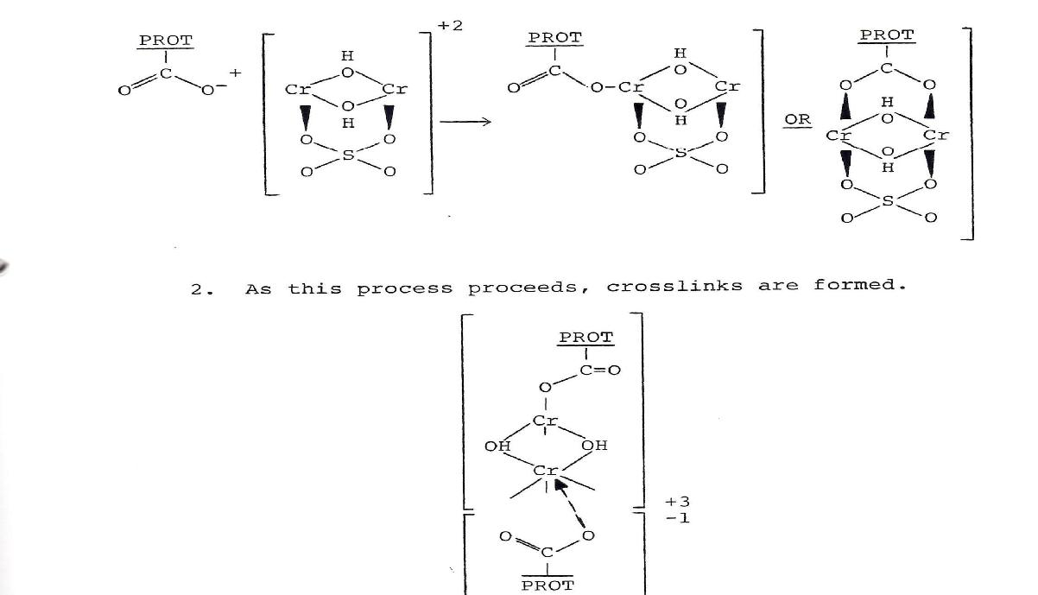

38 | P a g e

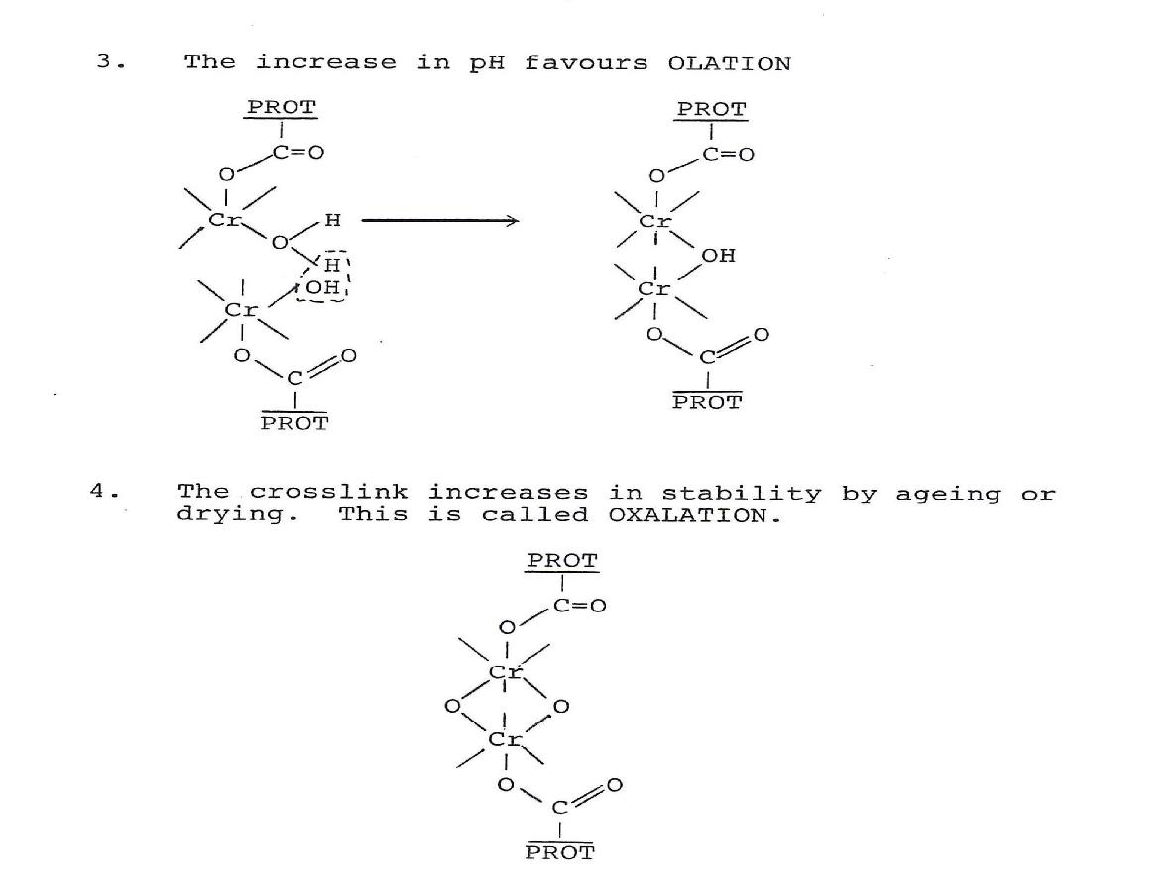

Subsequent to application of the chromium agent, the bath is treated with sodium bicarbonate to increase the pH to 4.0–4.3. This increase induces cross-linking between the chromium and the collagen. The pH increase is normally accompanied by a gradual temperature increase up to 40 °C. Chromium's ability to form such stable bridged bonds explains why it is considered one of the most efficient tanning compounds. Chromium-tanned leather can contain between 4 and 5% of chromium. This efficiency is characterized by its increased hydrothermal stability of the skin, and its resistance to shrinkage in heated water.
Tawing

Tawing is a method that uses alum and aluminium salts, generally in conjunction with other products such as egg yolk, flour, and other salts. The leather becomes tawed by soaking in a warm potash alum and salts solution, between 20°C and 30°C. The process increases the leather's pliability, stretchability, softness, and quality. Adding egg yolk and flour to the standard soaking solution further enhances its fine handling characteristics. Then, the leather is air dried ("crusted") for several weeks, which allows it to stabilize. Tawing is traditionally used on pigskins and goatskins to create the whitest colors. However, exposure and aging may cause

39 | P a g e

slight yellowing over time and, if it remains in a wet condition, tawed leather will suffer from decay. Technically, tawing is not tanning.

Depending on the finish desired, the hide may be waxed, rolled, lubricated, injected with oil, split, shaved and, of course, dyed. Suedes, nubucks etc. are finished by raising the nap of the leather by rolling with a rough surface.

The first stage is the preparation for tawing. The second stage is the actual tawing and other chemical treatment. The third stage, known as retawing, applies retawing agents and dyes to the material to provide the physical strength and properties desired depending on the end product. The fourth and final stage, known as finishing, is used to apply finishing material to the surface or finish the surface without the application of any chemicals if so desired.

Vegetable tanning

Vegetable tanning uses tannin. The tannins (a class of polyphenol astringent chemical) occur naturally in the bark and leaves of many plants. Tannins bind to the collagen proteins in the hide and coat them causing them to become less water-soluble, and more resistant to bacterial attack. The process also causes the hide to become more flexible. The primary barks, processed in bark mills and used in modern times are chestnut, oak, redoul, tanoak, hemlock, quebracho, mangrove, wattle , and myrobalan. Hides are stretched on frames and immersed for several weeks in vats of increasing concentrations of tannin.

Vegetable tannage, is common with other methods of tannage, has two phases: penetration and fixation. Penetration is favoured by adjusting the pH of the tanning system to a level somewhere near to the iso-electric point of the pelt; at this level, the vegetable tanning material will penetrate without fixing. The pH of the system is then modified to favour fixation by lowering the pH. This brings about the increased ionization of the amide groups in the protein, providing more positively-charged sites for the negatively-charged tanning material to react with.

Oil Tannage or 'Chamoising'

This form of leather is produced through the oxidation of oils that are applied to the hide. The leather tends to be flexible and readily absorbs and expresses water. Today, chamois is one of the few true oil tanned leathers still available. Chamois leather sometimes known as a wash-leather is a type of porous leather that is favored for its gentle, non-abrasive composition and absorption properties. It has a range of uses:

40 | P a g e

- Gloves in the 19th to the first half of the 20th century

- Leather jackets, small bags, and pouches

- Polishing cloths for jewels or shoes

- Filtering fuel

- Automotive drying material that is safe on acrylic, lacquer, enamel, and polyurethane paints and clear-coats

- Grips on sporting gear — chamois grips are used in field hockey and golf.

- General household cleaning

- Orthopedics and other medical uses

SAMMYING/SETTING

This process reduces water content to about 55% and can be achieved by a number of machines, the commonest being sammying machine. Setting out machine stretches out and the grain side is smoothed and also reduces the water content to about 40%. Sammying machine operates only in the feed out mode, different from setting machines most of which are reversible to make more intensive repeated localized setting possible. The so called Sammy setters combine both operations. Spreading and setting cylinders used are variously bladed and for the sake of consistency in technology are also referred to as knife cylinders when describing considerations
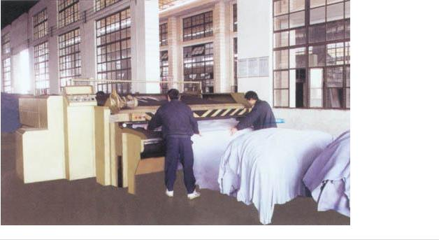

41 | P a g e

The thorough fed sammying and setting out machine is a hydraulic machine used for the removal of excess water from the leather after dyeing, before the vacuum dryer. The pressure is given by a pressing cylinder working from the bottom to the top. The machine is equipped with a hydraulic circuit that allows it to have an optimum pressure on all area of leather. The machine has a stretching system that stretches all the leather area uniformly. The leather is completely stretched in its entire surface. The first part of leather is stretched by the first group of two cylinders, and when the skin enters in pressure, the second group of two cylinders starts to work. In this system we reach the whole stretching, having a setting out effect and obtaining a very good stretching result on sides, splits and whole hides.
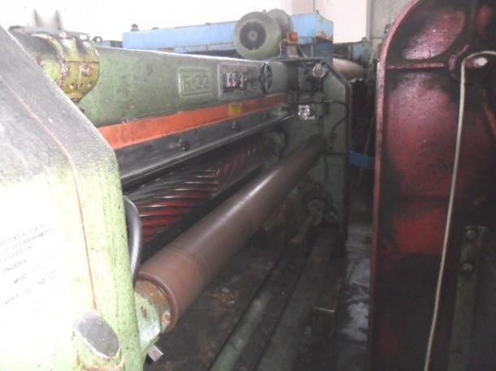

Features of Through-feed Sammying Machine:

- The optimal feed speed can be attained according to the requirement of different leather.

- The setting-out blade roller is equipped to stretch the leather, with a good setting-out effect. No crease on the leather after it is processed.

- A variable volume pump and a high-capacity accumulator are installed on the hydraulic system to ensure the stability of working pressure and uniform sammying effect. In addition, it also can save energy and protect components.
- The felt tension rollers at the top, front and back area are covered with high-quality fiberglass, which are corrosion-resistant and have a long service time.

42 | P a g e

5. It is especially suitable for the whole cattle hide, which can relieve the work strength, improve the productivity, and achieve non-stop operation.
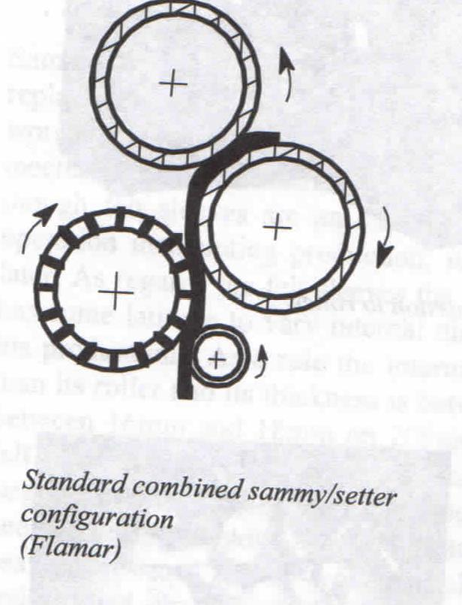

43 | P a g e

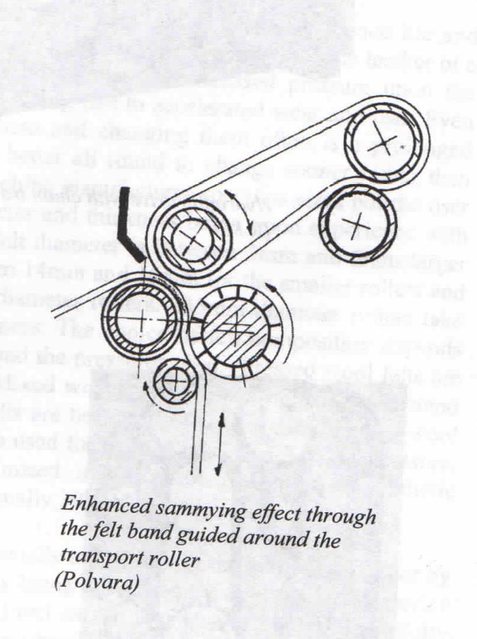

SPLITTING AND SHAVING

A splitting machine slices thicker leather into two layers. The layer without a grain surface can be turned into suede or have an artificial grain surface applied. A uniform thickness is achieved

44 | P a g e

by shaving the leather on the non-grain side using a machine with helical blades mounted on a rotating cylinder.

Shaving

This process is generally carried out on wet stock. The leather are therefore dipped in water, normally the day before to allow thorough penetration of the water. The leathers are then "set out" to remove any creases and pleats that had dried into the leather. This process is carried out by a setting out machine that consists of two rollers, and a blunt spreading helical blade that stretches the leather as described previously.

Fig.1 illustrates a side view of a typical shaving machine. The skin (D) is fed past a feed roller (E), and then between the thicknessing feed roller (C) and the shaving cylinder (F). The thicknessing feed roller is engaged by pressing the foot pedal (A) and can be adjusted towards or away from the shaving knife depending on the final substance that is required. The shaving cylinder is kept sharp by regularly sharpening the blade using a grind stone (H), and the impeller (I) spins anti-clockwise to ensure that the skin does not become wrapped around the shaving knife.

Shaving of skins has two important objectives, firstly to level out the substance (thickness) of the leather, and secondly to bring the substance to a precise figure.

45 | P a g e

Hides and skins all have areas where the substance is naturally heavier - the spine, the butt and the neck, and areas where it is noticeably thinner - the bellies. The act of shaving the skin reduces the variation that occurs, although in many cases, the substance will still be less in the belly edges. The shaving machines can shave to a surprising degree of accuracy - down to ±.05. As mentioned one of the functions that have to be carried out by the sorter is to grade the skins for substance. The reason for this is that it is important that too much of the skin's substance is not removed. If a skin that could make an end substance of say 2.0mm was shaved down to 0.6mm the leather produced would be equivalent to a skiver with very little of the corium being left, and would result in a very weak skin. Care therefore has to be taken to ensure that only a minimal amount of shaving takes place wherever possible.

Fig.2 shows the shaving cylinder, you will note the helical nature of the blade. There are two helixes meeting in the middle of the cylinder. As the blade spins, the blades stretch the skin both lengthways and sideways, and in the process remove the majority of creases that are present in the skin.

NEUTRALIZATION

In chemistry, neutralization is a chemical reaction in which an acid and a base react quantitatively with each other. Acids and alkalis react together and therefore one cannot have both acidity and alkalinity in the same solution. It will be seen that acid additions or process are given to pelts to neutralize or kill alkalinity and vice versa. For example;

NaOH + HCl = NaCl + H₂O

If the exact amount of HCl is added to a given quantity of NaOH, all acidity or alkalinity is lost and a neutral salt solution remains. This type of reaction is commonly used in such processes as

46 | P a g e

deliming, depickling, neutralizing and basifying. Neutralization is the removal of residual chemicals and prepares the leather for further processing and finishing.

After tannage, the charge on the leather is zero at the pH of the iso-electric point. At pHs below this is cationic, i.e. positive, when the leather surface will react immediately with the common colloidal anionic retans, dyestuffs and fatliquors giving uneven distribution and poor penetration of the fibre structure. At pHs above the iso-electric point, the leather will be anionic so that there is no rapid ionic fixation leading to even distribution, penetration and often less fixation.

Typical iso-electric points for various tannages are;

Aldehyde | Syntan | Vegetable | Limed | Raw | Masked | Simple | Alum | Zirconium
 |  |  | hide | hide | Cr | Cr
2.5 | 3.3 | 4.0 | 4.7 | 5.2 | 6.0 | 6.7 | 7.2 | 7.5

Chrome tanned leather is acidic and develops acidity on standing (it is +ve charge), and this is accentuated by the mineral tannage. Consequently negatively charged colloids such as dyestuffs, vegetable tans, sulphated oils, etc will readily precipitate on the skin surface. Neutralizing removes the acidity in the leather and hence reduces the cationic charge, so that there is less reaction with these anionic materials, which then penetrate the leather more uniformly and thoroughly.

RETANAGE

The purpose of retanning is to produce a further stabilization of the collagen network. This involves further processing of the stabilized collagen network and may comprise a further tannage when special characteristics such as perspiration resistance are required. The tanned leather is subjected to additional tannages (e.g. with combinations of chrome, vegetable, glutaraldehyde or syntan agent) with similar or new tanning materials. These agents may be used to lighten the colour of the leather, to produce a feeling of fullness and to aid in the penetration of dyes. The choice of pretanning, tanning and retanning chemicals is dependent on the properties desired in the final leather, and therefore, on the properties required in the final leather product.

DYEING, FATLIQUORING AND DRYING

This stage includes preparing the retanned material for finishing by processing through to dried crust.

Dyeing

47 | P a g e

Chromium tanned leather is blue in colour and must be dyed to obtain the desired colour. The dye acts as a base colour for finishing, and the depth of dye penetration and leather colour are of great importance.

Fatliquoring

Chromium tanned material dries out hard and crusty and is unsuitable for most purposes. Small quantities of oil, present as emulsions known as fatliquors, make a significant difference to the handle, ie the fullness, softness and flexibility, among other factors.

COMPARISON OF VARIOUS RETANNAGES 1. Vegetable retannage

The leather is chrome tanned then retanned with vegetable tanning material. The retannage improves the fullness or firmness, tightening and filling the grain. It is popular where the grain is to be buffed to produce corrected grain finishes. By using 2 - 3% soluble or semi soluble quebracho extract in natural colored leather results in leather with clearly defined chrome characteristics but with a smoother grain, slight flank filling and better properties.

2. Aldehyde retannage

Formaldehyde is a tanning material which is soluble in water and most organic solvents. Aldehyde combines with the basic amino groups of the skin. It can be used prior to other tannages to set the grain. It has ability to impart chemical and hydrothermal stability to hide fiber. It is also capable of stabilizing other tannages, such as mineral and vegetable tannages. It has the additional advantage that it yields white tanned leather, and such white leathers yield exceptionally bright colored dyeings. Glutaraldehyde pretannage or retannage of chrome tanned grain splits of ox hide is favoured to give better strength. As a light pretannage to vegetable tannages it reduces initial astringency of the tans but does not give such pale shades as many syntans.
3. Chamoise (or oil) retannage

Combination tanned chamois is produced by either pretanning with aldehydes which makes preparation for oiling easier and gives less danger of ‘burning’during chamoising or by replacement of some of the cod oil with synthetic aliphatic sulphonyl chlorides.

4. Syntan retannage.

Syntans lack the ‘filling power’and give undesireably thin papery leather. They have particularly useful properties, however, when used in conjunction with other tanning materials.

48 | P a g e

Other materials which may be used in combination with other tanning agents to provide special properties desired in leather are resins and polymeric additives.

DRYEING AND ASSOCIATED OPERATIONS

All the tanning processes are carried out with water so leather needs to be dried. The retanning, dyeing and fatliquoring chemicals are allowed to penetrate and distribute within the collagen fibre structure before the pH is lowered and the astringency causes them to "fix" to the tanned material. The final binding of chemicals is encouraged by the drying process. Batches of leather are commonly toggle dried on frames in heated tunnels for four to six hours or are vacuum dried individually for two to ten minutes. Drying is usually followed by buffing, conditioning and staking or milling. The resultant crust material is resistant to microbial attack and contains all the leathering properties desired of leather and is ready for finishing. The choice of the drying system depends not only on economic factors but also on the end-use material.

Drying methods

- Vacuum drying –The damp leather is slicked out on a heated stain resistant smooth metal plate. This supplies heat to the leather by conduction. The hood is then lowered on to the metal, and the rubber lips make a gas tight seal with the plate. The air pressure in the hood space can be adjusted and by pressing the diaphragm (which has a gas tight fitting) and felt, holds the leather in close contact with the hot plate. The leathers are slightly dried, and the fibers are fixed by doing so.

- Hanging drying –The leathers are not yet fully dried. The last drying process is carried out by hang drying. Here, any remaining moisture in the leathers evaporates. Chemical reactions in the hide now have enough time to take place, and the moisture within the hide has time to spread evenly. By removing moisture, the chemicals added before connect better with the skin fibers. This raises the fastness and later gives the leather a more comfortable feel. Feel, technical, and visual characteristics are improved.
- Paste drying –A glass plate covered with a thin starch paste and the wet leather slicked out on this, grain side to the glass, to which it adheres, thereby preventing shrinkage on drying.

- Drying under tension –The simplest method is nailing the slicked out leather stretched on boards. This enables it to be adjusted to some extent. Toggling is similar in principle but the wooden frame is replaced by toggling frames either of heavy gauge wire mesh or perforated metal.

49 | P a g e

- Radiant heat drying –Heat supplied as infra red either by electrical heaters or tubes heated by the catalytic oxidation of gas, e.g. propane or butane. The wet leather looses moisture by evaporation due to high temperatures.

- High frequency drying – The damp leather is passed between two plates which are electrically connected to a generator producing high frequency alternating current.

Effects of leather produced by:

- Sammying –Sammying is the removal of excess water after tanning using a machine known as sammying machine. The blunt helically bladed cylinder stretches out the skin while pressure is exerted by two rollers. A setting roller may also be incorporated to eliminate any creases in the leather before any nip pressures are applied. It is usual to give it a process of drying out in a suitable condition to allow for even distribution.

- Setting out –Sammying and setting is done by one machine presently. The effect of setting out is that the leather gains flatness, shape, size and area yield. In case all these are of no importance, centrifuge (hydro-extractor) or hydraulic press can be used.
- Conditioning – This is the adjustment of the moisture content of leather by giving it a required percentage of moisture. Splitting and shaving machines work better when the leather is pliable and flexible enough to bed down on the feeding rollers, but if it is too soft or loose the fibres tear and drag rather than cut clean.
- Stacking –This is the piling of leather using a machine. Leather can be stacked or horsed up after tanning. A stacker is one of the most important workhorses in any modern major tannery for they are used for sorting leather into different selections and grades. The grader uses stacking to help in sorting grains from splits in the splitting process. Stacking as used for the purpose of horsing up is important in helping further crosslinking after tanning.

FINISHING

Objectives: This is the preparation of the tanned material in a manner suitable for use or for sale. The common finishing processes include drying, thickness modification, dyeing, oils or fats may be needed to improve suppleness or water resistance, handle improvement and grain improvement.
Removal of surplus tans done by piling or horsing up for the surplus tan liquor to drain slowly. Washing in case of light leathers but in case of heavy vegetable tanned leathers, piling or horsing up is recommended. Chrome tanned heavy leathers may also be washed.

50 | P a g e

Neutralising is done to the leather to make it less reactive to allow for penetration. The charge on the leather is zero at the pH of iso-electric point. Below is cationic (positive) and above is anionic (negative). Uneven distribution of chemicals in finishing processes (retanning, dyeing and fatliquoring) is experienced in case neutralizing is improperly done.

Adjustment of thickness is done by splitting and shaving. Removal of excess water is done by samming, setting and drying

Finishes: These are varieties of coloured pigments, binders, waxes, etc, applied to the leather to impart certain required properties. Both the composition and application of the finishes are varied to suit the requirements of the end product; not only in terms of colour, gloss, handle, resistance to water, solvents, heat, flexing, rubbing etc, but also in terms of uniformity of surface appearance. A finish process and finishing chemical must be carefully designed and "married" with the production of the crust to ensure compatibility. The finish may be required to hide defects, to contribute to the leather beauty and properties and to provide fashion effects. Resins, pigments, dyes, handle modifiers, fillers, dullers and other chemicals are added in layers to the surface of the leather by spraying, roller-coating, curtain-coating or by hand. Heated hydraulic or roller presses are used to produce smooth or patterned leathers, depending on customer requirements. Finishing finally completes the leather manufacturing process and the area is then measured and the leather sent for dispatch to a product manufacturer to be turned into shoes, clothing or upholstery.

Varieties of finishes

Seasons –A transparent film or coating applied to the leather to modify gloss, handle or fastness properties but leaves the natural appearance of the leather visible (aniline look). These are viscous solutions of water soluble colloids, ranging from protein (caseins, egg-white, gelatin and blood albumen) to starches (starch, dextrin, etc.)

Binders –Seasons modified by addition of non-film forming dyes, waxes, oils and pigments to bind or stick the additives to the leather surface. More sophisticated products are being used in the market today which has now included non-water based systems. Protein binders are used on a large scale in the leather industry, and are based on casein, albumin and synthetic polyamides. They belong to the group of non-thermoplastic binders so they do not soften when temperatures are increased in finishing. Leathers can therefore be plated and embossed at high temperature without becoming tacky. In addition these binders can be used to provide a strong glazing effect.

51 | P a g e

When used with acrylic, butiene or polyurethane binders, the natural tackiness that these products exhibit is reduced. Protein binders withstand the hot iron test, but in order to enhance the fastness to wet rub, crosslinking with formaldehyde is required.
Pigment –These are ground coloured natural rocks or ores (e.g. iron oxides) to fine powders, or roasting these ores (e.g. titanium dioxide), or by chemical preparation (e.g. lead chroamates). Unlike dyestuffs, pigments are insoluble in water or solvents and are opaque. The bulk of leather producing materials suffer some grain imperfections and considerable ingenuity is required in hiding these. The most effective and common method is by pigment finishing.

Cross-linkers – These are chemical substances that react with various binders, improving physical properties such as resistance to dry and wet flexing, fastness to wet rub, water and solvent resistance. Other characteristics are modified, such as embossing behaviour. Normal crosslinking eliminates or reduces print cut, while excessive crosslinking prevents a good retention. There are different types of crosslinkers. Zinc oxide is mainly used for butadienic resins, whereas formaldehyde, together with polyaziridine, is the principal crosslinker for protein binders. When using crosslinkers in finishing formulations, it is important to consider the reduced pot-life of the blend. This depends not only on the type of crosslinkers used, but also on the type of binder. All crosslinkers, except zinc oxide, are considered harmful and must therefore be handled with great care and with strict regard to health and safety.

Polyester chain Polyester chain
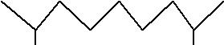
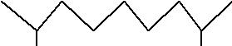

 | OH | OH |  | O | OH
di-iso- | NCO | NCO | Cross | CO | CO
cyanate |  |  | linked | NH | NH
 |  |  | polyurethane
 |  |  | on
 | NCO | NCO | curing | NH | NH
 | OH | OH
Polyester chain |  |  |  | CO | CO
 |  |  |  | O | O
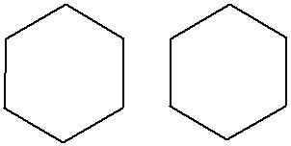
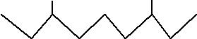
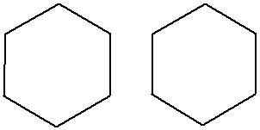
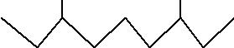
Polyester chain

52 | P a g e

Fillers – Fillers are finishing auxiliaries usually added to formulations in order to increase covering power, fullness, the embossability of the finish and to reduce tackiness. Care should be taken so that certain properties (like handle, buffing properties, tightness of the grain, the fine grain or the dyeability) of the leathers are not interfered with when treating leather with fillers.

Methods of finishing application

- Brushing and Padding – In case the coagulation is not very rapid, this type of application ensure uniform penetration of the binder into the surface and good adhesion or anchorage of the finish. If coagulation is too rapid, the film will be deposited superficially and may be broken up or crumble with the action of the pad.

- Spraying –This is the application of finish solution by the use of spray gun by gravity or compressed air where it is ejected from a fine nozzle or orifice by pressure as a spray of fine atomized droplets which are blown onto the leather surface. Spraying types are;

  - Transverse head spray –The guns are mounted on a bridge above the conveyor and oscillate at a uniform speed from side to side. Automated system will ensure uniform spraying and 75% of the finish being lost as overspray.

  - Rotary system –The guns are mounted on the arms of a rotor which rotates above the conveyor band. The uniformity is controlled by the dosage of the gun which can be controlled by adjusting the nozzle using a needle and the speed of the conveyor band.
  - Airless spray –The finish is ejected from the gun under pressure without air, so less drying of the vapour occurs during spraying. It is preferred for heavier bottom flood or wet coats.

- Curtain coating – The principle of this system is that the finish is in continuous circulation, flowing from reservoir to pumps via a filter to a header tank in the orifice type through a slit as a uniform liquid curtain, into a collecting trough, and back to the reservoir. The amount deposited will depend on the amount of flow and the speed of the conveyor. Excellent with high rates of production.

COMPARISON OF PROTEINS, RESINS AND NITROCELLULOSE Protein binders

Protein binders are used on a large scale in the leather industry, and are based on casein, albumin and synthetic polyamides. They belong to the group of non-thermoplastic binders so they do not

53 | P a g e

soften when temperatures are increased in finishing. Leathers can therefore be plated and embossed at high temperature without becoming tacky. In addition these binders can be used to provide a strong glazing effect. When used with acrylic, butiene or polyurethane binders, the natural tackiness that these products exhibit is reduced. Protein binders withstand the hot iron test, but in order to enhance the fastness to wet rub, crosslinking with formaldehyde or polyaziridine is required.

Resins

Acrylic resin binders are used for leather finishing because of their endurance, flexibility and good resistance to heat and light. It is also possible to produce acrylic resins which have the ability to self crosslink, the advantage being the final film has excellent improved resistance to wet and dry rubbing and good resistance to solvents. In general, the most widely used resins are those which dry to give medium type films.

Nitro-cellulose lacquers and emulsions

These can be divided into aqueous NC-emulsions and solvent-borne NC-lacquers. Both are used as light top coats or intermediate coats to facilitate embossing. There are gloss and dull versions, which allow flexibility and provide good rub resistance and water fastness. The degree of softness and elasticity can vary widely, depending on the quantity of plasticiser used in the mixture. Because of their limited lightfastness, nitrocellulose lacquers should not be used in white leather finishes or on upholstery leathers. After a period of time, plasticisers can migrate from the surface causing a brittleness of the film.

Tanning of shoe upper leather

SHOE UPPER LEATHER

Raw material: Wet salted Kenyan Hides

Soaking –Soaking of wet salted hides is best done in two stages, i.e. dirt soak which removes dirt, dung and the curing salt, and the main soak which hydrates the hides to near normal freshly flayed condition.
Dirt soak in |  | Add
pit, paddle or |  |  | The hides are agitated 5mins/hr for
 |  | 250 –400% H₂O @20ºC
in drum |  |  | 2hrs. Drain brined solution
 |  | 0.2 –0.4 g/l soaking agent
Main soak |  | 250 –350% H₂O @20ºC | The hides are agitated 5mins/hr for 4-
 |  | 0.2 –0.3 g/l disinfectant | 5hrs or left overnight. Drain
 |  |  | 54 | P a g e

Pre-fleshing |  | This helps liming chemicals to act evenly and is considered a useful step
Drum liming |  | 30 –40% H₂O @20ºC
(2rpm) |  | 0.1 –0.15 non ionic grease and scud | Drum 5mins
 |  | dispersant
 |  | 1.5 –2.0 sodium sulphhydrate. NaHS
 |  | (70%) | Drum 20 –30mins
 |  | 2% sodium sulphide conc (60%) | Drum continuously for 20mins. Further
 |  |  | drumming for 3-5mins/hr for 2.5hrs
 |  | 3% slaked lime
 |  | 270% H₂O | Drum for 5mins/hr for 4-5hrs. Rest
 |  |  | overnight (12-15hrs). Drain bath
Rinsing |  | 300% soft H₂O @30ºC | Drum 5mins
Fleshing
Washing |  | 250% soft H₂O@25ºC | Drum 10-15mins. Drain
Deliming |  | 100% H₂O@30ºC
 |  | 0.5% Ammonium sulphate | Drum 20mins. Drain out half of the
 |  |  | bath
 |  | 0.2% Sodium bisuphite
 |  | 2% Ammonium sulphate | Drum 15mins
 |  | 0.15 –0.3% Formic or HCl (1:10)
 |  | 0.2% non ionic grease and scud
 |  | dispersant | Drum 30-40mins. float pH 8.2 –8.5
Bating |  | 100% H₂O@32ºC | Drum 30mins. The float pH is
 |  | 0.3% enzymatic bate. | maintained between 8.2&8.5 by adding
 |  |  | formic acid if necessary. Drain bath
Washing |  | 200% H₂O@25ºC | Drum 15mins. Drain
Pickling |  | 40% H₂O
 |  | 7% Salt to make 8ºBe | Drum 10mins
 |  | 0.3% formic acid (1:10) | Drum 15mins
 |  | 0.8% sulphuric acid (1:10) | Drum 1-1.5hrs. Float pH 2.6-2.8
Tanning |  | 3-4% basic chrome crystals (33%
 |  |  | Drum 30mins
 |  | 0.3-0.4% electrolyte-stable fatliquor
 |  | 0.7-1.0% sodium phthalate (in powder
 |  |  | 55 | P a g e

 | form) |  | Drum 2hrs
 | 0.3% Magnesium oxide (fine powder)
 |  |  | Drum 2hrs
 | 0.3-0.5% Sodium acetate (1:5)
 | 0.3-0.5% Sodium acetate (1:5) |  | Drum 2hrs. Float pH 3.6-3.8 –The end
 |  |  | pH is normally kept below 4.0
 | 30 –40% H₂O @35ºC |  | Drum 60-90mins Drain
Horse up or pile | overnight.
Sammying, setting, splitting (1.8 -2.0mm) and shaving. Weigh shaved weight
Washing of | 200% H₂O @40ºC. sometimes small
shaved leather | additions (0.1-0.2%) of formic, acetic |  | Drum 30mins
 | or oxalic is added to remove Cr stains
Neutralization | 150% H₂O @35ºC |  |  | Drum 45mns
 | 1.5% Naphthalene sulphonic acid condensate pH 1.7
Wash | 200% H₂O @20ºC (cold wash) |  |  | Drum 10mins drain
Wash | 200% H₂O @40-45ºC (hot wash) |  |  | Drum 10mins drain
Dye | 100% H₂O @45ºC |  |  | Drum 5mins
 | 1% dye leveling syntan
 | 1% suitable dye |  |  | Drum 30mins
Fatliquoring | 1.5% sulphited fish oil
 | 1.5% raw groundnut oil
 | 1.5% Cationic fatliquor (50%) |  |  | Drum 30mins
 | 2% egg yolk (or substitute)
 | 1% china clay
 | 2% Phenolic retanning, dispersing syntan |  |  | Drum 1hr. Check pH
 | 2% Mimosa extract
 |  |  |  | 3.5/3.6 then horse up
 | 2% Basic chrome crystal 33% basic (dissolved in a
 | little water) all added in a single feed

COMMERCIAL ASPECTS OF LEATHER PRODUCTION

Tannery costing

56 | P a g e

The financial accounts, profit and loss balance sheet are vital in understanding the financial position of a business. However from the point of view of aiding day-to-day management they present an incomplete picture for two reasons:

- They are historical. Action to correct a problem has to be taken immediately and cannot wait until the difficulty is revealed in the final accounts.

- They are a picture of the business as a whole. Management decisions have to be made in respect of each individual activity of the business.

A small tannery manufacturing for example, three products could produce the following profit statement
 | £(000)
Sales | 1300
Less all expenses | 1170
Profit | 130
An overall profit of 10% on selling price but a very different picture is obtained if further analysis of the figures is carried out.
 | TOTAL |  |  | PRODUCT ANALYSIS
 |  | £(000) | A£(000) |  | B£(000) | C£(000)
Sales |  | 1300 | 500 |  | 400 | 400
Less expenses |  | 1170 | 400 |  | 432 | 338
Profit (Loss) |  | 130 | 100 |  | (32) | 62

It is shown therefore that products A and C heavily subsidize product B. It may be of course, that this is deliberate policy but management must have this information at its disposal.

Obviously additional information is required in order for management to do its job. Costing provides up to date operating results of individual products, processes or department.
Expenses

1. Direct expenses –Those items of expense which can be directly related to the production and which increase in direct proportion to the volume of production. Some of these are:

- Direct labour –This is based on productive labour hours obtainable from time sheets or job cards and is priced at the appropriate rate. In a tannery, labour will represent about 15% of total cost. The organization and remuneration of labour therefore is a very important aspect of leather production.

57 | P a g e

- Organization – Inefficiencies cause cost to increase rapidly. Method study is designed to obviate this problem. Good working methods will reduce cost not only in terms of labour saving but also by preventing damage to goods.
- Remuneration – The remuneration of productive labour in most production operations can be divided as follows:

· Basic rate –That part of payment which is paid whether or not productive work is done.

    - Performance bonus/piecework –That part of the rate which is paid in direct proportion to efficiency or output.

    - Merit rate –A payment for skill and ability.

    - Local rate –That part of the rate which is paid in order to employ and retain labour in a particular locality.
- Direct materials –This item of expense represents a total of 60-65% of tannery cost, and once again it increases in direct proportion to the volume of production. It has to be further sub divided into:

  - Raw hides and skins costs

  - Process chemicals

  - Consumables

The total of these direct items is known as PRIME COST.

2. Indirect expenses –Those expenditures which cannot be related to particular production lines because they are incurred for the benefit of all. These direct expenses are overhead and can be divided further:

- Production overhead – This includes the following items or the proportion of them which is related to production:

  - Rent and rates

  - Energy

  - Maintenance/labour and materials

  - Production management

  - Supervision

  - Bank interest

  - Depreciation

58 | P a g e

The totals for these figures are obtained and then reallocated in order to produce a realistic cost for each cost centre or department. This is necessary because overheads are not incurred uniformly throughout the tannery, and a large part of it is related to time. One method of overhead absorption is therefore to calculate an hourly rate of overhead viz:

Production overhead for the period Production hours in the period

This method takes into account the passage of time but not the fact that overhead is not incurred uniformly; 100hours of trimming should not be charged the same overhead as 100 hours shaving. Therefore several bases are used:
- Floor space, e.g. rent, rates and lighting.

- Number of employees, e.g. canteen, welfare supervision, time keepers.

- Production hours.

- Technical estimate, e.g. maintenance, internal transport, power, depreciation, effluent treatment.

Cost of production therefore is Prime cost + Production overhead and reflects the accumulated cost of the product coming off the shop floor

- Administrative overhead –This include general office salary, communication cost, office power, depreciation and maintenance of office equipment. A flat percentage method is often used for absorbing this part of the overhead, simply

GENERAL WAREHOUSING TECHNIQUES

Warehousing Techniques are the systematic ways and means of receiving, storing, protecting and issuing articles and commodities for future use. This covers most stages in the process of warehousing received goods and shows how good techniques can improve the efficiency and economy of a warehousing organization. The production processes in a tannery can be split into four main categories: hide and skin storage and beamhouse operations, tanyard operations, post-tanning operations and finishing operations. After the hides and skins are flayed from the carcass at the abattoirs, they are delivered to the hide and skin market, directly to the tannery or to the fellmongery. Where necessary, hides and skins are cured before transport to the tannery in order to prevent the hides and skins from putrefying. Upon delivery to the site, hides and skins can be sorted, trimmed, cured and stored pending operations in the beamhouse.

59 | P a g e

Moulding can be a problem in damp climates or if dried skins get wet during storage. The hide fiber is hydrophilic, meaning that the fibers of the skin attract moisture; if the atmospheric humidity is high enough, the skin can draw excessive moisture from the air and become damp enough to mould. Storing dried skins in a dry area, away from any potential drips, should prevent moulding. We have, on occasion, seen some mould on our salted skins. We don’t know why and don’t know how to prevent it. Salt is also hydrophilic; so, if you are storing skins which have been scraped but from which all the salt has not been rinsed, they will attract more moisture from the air than a skin which has never been salted. This attracted moisture may lead to slow decay and mould, since there will not be enough salt left in the skin to preserve it. Therefore, it is best not to leave skins in a “half salted”state, unless the air is very dry.

Grease-burn happens when a skin is dried with fat left on it and is then exposed to heat. The fat melts into the skin and weakens (destroys) the fiber structure. Badly grease-burned skin is very weak and will tear and fall apart when subjected to the rigorous tanning process. Grease-burning is easy enough to avoid, just be sure to flesh or peel all fat from the skins before drying them.
Pests boil down to dogs and a few insect species like bugs. Dogs can be infuriating. They will literally eat skins, wet or dry, be careful. There’s never had a problem with bugs in salted skins, but some bugs might be resistant to salts. The bug problems have all been in unsalted dried skins. Dermestid beetles and clothes moths have been the culprits, and once your hides are infested; their population can grow at an exponential rate. The larvae eat skin, the damage appearing as little pathways of missing hair or tissue. If left too long, they will chew holes all the way through the dermis, leaving numerous holes and thin spots. The moths even invade residential houses and get into clothes and dried foods.

60 | P a g e

