UNIVERSITY OF NAIROBI

COLLEGE OF AGRICULTURE AND VETERINARY SCIENCES DEPARTMENT OF PUBLIC HEALTH, PHARMACOLOGY AND TOXICOLOGY JLS 204: TANNERY ENGINEERING-

LECTURE NOTES

INTRODUCTION

The objective tannery engineering is to learn about the principles, the construction and the functions of the commonly used machines in the tannery. Leather manufacture started in the BC centuries when every process was manual but with time there has been evolution of technology in that a material which used to take months to produce can now be produced with the help of machines and technology in just 24hrs.

ENGINEERING PRINCIPLES Measurement

The objective is to provide production and Engineering Management and Personnel in the tannery with reference information most likely to be encountered in their work.

Units and conversions

The two main systems in general use throughout the world are the metric and the imperial system.

The imperial system developed in Britain and is based on the yard, the pound and the second. The 1963 Weights and Measures Act recognized metric units as fundamental by defining the pound and the yard in terms of the metre and the kilogram.

The metric system was developed in the eighteenth century in France originally as the CGS system (centimeter/gram/second) followed by the MKS (metre/kilogram/second). With additional units and a more precise definition of the metre this has been named the Syste’me International de’Unit’es for which the SI is recognized in all languages.

SI units The system is decimal and is defined in terms of seven basic units and two supplementary units. All units in any technology can be expressed in terms of these units which are as follows;

Quantity | SI unit | Symbol
Length | metre | m
Mass | kilogram | kg
Time | second | s
 |  | 1

Electric current | ampere | A
Temperature, (thermodynamic) | kelvin | K
Amount of substance | mole | mol

Frequency: The hertz (Hz), number of regular repetitions per second. 1Hz = 1 cycle per second.

Force: The Newton (N), the force applied to a body of mass 1kg giving an acceleration of 1 metre per second squared. 1N = 1kg m/s²
Pressure: The Pascal (Pa), the pressure produced by a force of 1 Newton over an area of 1square metre. 1Pa = 1N/m²

Work: The joule (J), the work done when the point of application of a force of 1 Newton is displaced through 1 metre in the direction of the force. 1J = 1Nm
Electrical potential: The volt (V) is the difference of electrical potential between two points of a conducting wire carrying a current of 1 ampere when the power dissipated equals 1 watt. V = W/A

Electrical resistance: The ohm (Ω), the electrical resistance between two points of a conductor when a potential of 1 volt is applied to these points produces a current of 1 ampere in the conductor. Ω = V/A Luminous flux: The lumen (lm) is the luminous flux emitted within a solid angle of 1 steradian by a point source of uniform intensity of 1 candela (cd). 1 lm = 1 cd sr

Illuminance: The lux (lx) equal to an illuminance of 1 lumen per square metre. 1 lx = 1 l/m²

Conversions
Length
Units | symbol | m | cm | mm | in
Metre | m | 1 | 100 | 1000 | 39.37
Centimeter | cm | 0.01 | 1 | 10 | 0.0328
Inch | in | 0.0254 | 2.54 | 25.4 | 1
Foot | ft | 0.3048 | 30.48 | 304.8 | 12
Area
Units | m² | cm² | mm² | in² | ft²
_{m}2 | 1 | 100 | - | 1550 | 10.76
cm² | - | 1 | 100 | 0.155 | -
in² | - | 6.435 | 645 | 1 | -
ft² | - | 928.03 | - | 144 | 1
Volume
Units | m³ | dm³ | in³ | ft³ | gal
 |  |  |  | 2

m³ | 1 | 10³ | 39.37³ | 35.31 | 219.969
dm³ | - | 1 | 61 | 0.031 | -
in³ | - | 0.01639 | 1 | - | -
ft³ | 0.028 | 28.317 | 1728 | 1 | 6.228
gal | - | 4.546 | 277.4 | - | 1
Mass

PROPERTIES OF MATERIALS FOR MACHINE CONSTRUCTION

Strength –Stress required to break a standard piece of material.

Stress –Force per unit area of cross section

Pa = N.m⁻² MPa = MN.m⁻²

Strain –Proportion of deformation produced under the influence of stress

Elastic material | Plastic material
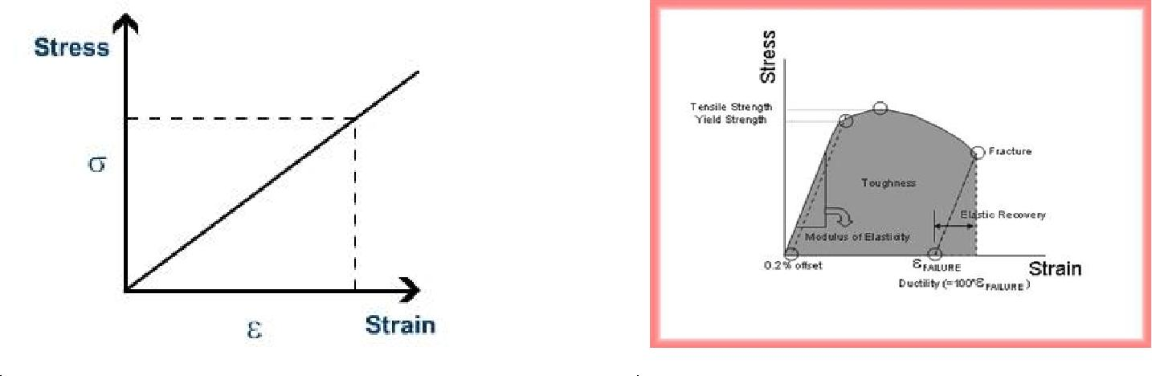
Plastic - Results when material is stressed to the extent where the elastic limit is exceeded

- Coincides with the movement of atoms etc. into permanent new position.

Malleability –extent to which a material can undergo deformation due to compression before failure Ductility –Degree of extension before failure. All ductile materials are malleable.

Toughness –The amount of energy required to fracture a standard piece

3

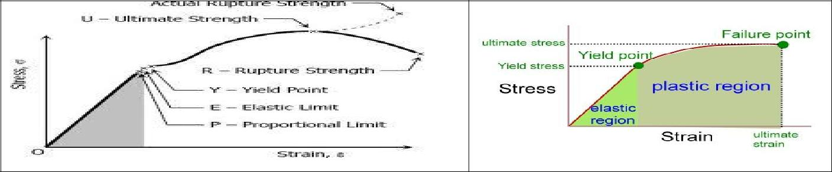

Hardness –Ability of a material to resist surface abrasion

- Difficult to measure

- Measure the resistance of the surface layer to penetration by an indenter

Brinnell Test | Vickers diamond test
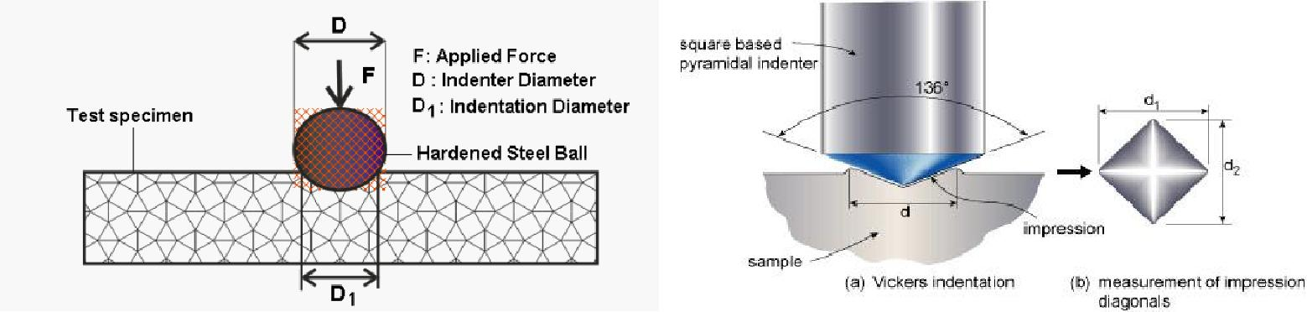
Metals (properties) –Shiny clean (luster)

- Solids under ordinary conditions

- Usually conduct heat and electricity

- Malleable –rolled or hammered

- Ductile –drawn into wires

- Hard/soft

- Low melting/high melting Polymers –Molecular solid

- Thermosets

  - usually crosslinked

  - Permanently hard, when heated do not soften but char

  - Superior flexural hardness

- Thermoplastics

  - Soften when heated above their glass temp(t_{g}) –shaped, harden on cooling

  - Superior flexural and impact properties

Wood

4

- Molecular solid

- Structural material

- Secondary xylem of conifers (softwood) and dicotyledonous (hardwood)

- Poor conductor of heat and electricity

- Moderate weight

- Shock resistant

- Stiffness

- Strength e.g. Iroko (cleopara excels)

- Hardwood

- Other names kambala, muuk, odum, intule, tule –found sothern half of Africa

Properties –Medium hardness and weight, bending and crushing strength, high decay resistance and good stability, very low stiffness and shock resistance, moderate steam bending.

Working

- Good gluing, nailing and screwing

- Polish to high finish

- Used as a substitute for teak

Alloys

- Extend the range of useful metallic properties and introduce new ones.

- A metallic solid or liquid consisting of an intimate association of two or more elements “solid solution”

- Atoms mingle on an atomic scale

- Principally metals

- Many non metals are important constituents

Steel –Iron age ±3500 years ago –smelting of iron ore. Almost all ferrous materials

- Carbon steels

- Alloy steels

- Cast irons

Derived from pig irons –relatively impure materials containing 10% C, Si, Mn, P and S

- Remove impurities via oxidation

- An alloy of iron and carbon (±2)

- Vary C content and heating to get different types of steel

- Can also add Ni, Cr, M

5

Stainless steel

Cr imparts high corrosion resistance to steels (13-21% Cr). High amounts of chrome make steel brittle so Ni is added instead.

Cast iron

- The cheapest metallurgical material in terms of cost per unit mass

- Good rigidity

- Good compressive strength

- Excellent fluidity

- Good machineability

With Si content

- Grey iron –Coarse graphite + ferrite (weak and soft)

  - Fine graphite + pearlite (strong and tough)

- Mottle iron –Cementite, graphite + pearlite (weak and brittle)

SERVICES IN MANUFACTURING INDUSTRY AND THE FUNCTIONS OF MAINTENANCE Services

The service provision to a manufacturing industry differs greatly depending on the type of goods produced. To the leather manufacturing industry, the services in general are;

- Water

- Electricity

- Compressed air

- Steam (hot water)

- Power –Electricity

  - National grid.

  - Generators

6

- Solar power, wind, water.

- Batteries

- 2, 3 phase, (AC or DC)

Functions of machines

A machine is a tool containing one or more parts that uses energy to perform an intended action. Machines are usually powered by mechanical, chemical, thermal or electrical means, and are often motorized. Historically, a power tool also required moving parts to classify as a machine. However, the advent of electronics has led to the development of power tools without moving parts that are considered machines. A simple machine is a device that simply transforms the direction or magnitude of a force, but a large number of more complex machines exist. Examples include vehicles, electronic systems, molecular machines, computers, television, and radio.

Maintenance of machines

Maintenance, to many organizations is a word which provides little value to an organization when in fact it provides great value to any company when development, management, and discipline are applied. What is most misunderstood about maintenance is the true objective of the function. The objective of maintenance is to maintain the assets of a company so that they meet the reliability needs at an optimal cost.
Maintenance’s main aim should be;

- To maintain flow of operation

- Keep in existing condition

- Preserve, protect components

- Keep from failure or decline

Machines must operate on the optimum return on investment. It is paramount that every manufacturing company to have a maintenance department. The main function of maintenance department is to ensure the availability of the machines to the production department. The cost of maintenance is part of the production cost. The most basic requirement is the up to date records of maintenance.

Emergency maintenance

- Loss of production

- Damage or loss of material

- Disruption of maintenance priorities

- Excess downtime due to unavailable spare parts

7

Development maintenance

- Modifying machines

- Filling improvements

- Installation of new equipments

Preventive maintenance

- Machine parts inspected as part of routine maintenance and a report is drawn up –plan of action.

- Must keep a historical record.

Routine

- Operate in conjunction with preventive maintenance

- Includes lubrication, adjustments for wear, replacement of consumable spares

  - time cycle

  - running cycle

  - annual overhaul

Dryers.

A dryer, or drying machine is a powered appliance that is used to remove moisture from a load of clothing and other textiles, usually shortly after they are washed in a washing machine. Clothes and leathers may also be dried by natural evaporation and, if available, sunlight on an outdoor or indoor clothes line or clothes horse.
Many clothes dryers consist of a rotating drum called a "tumbler" through which heated air is circulated to evaporate the moisture, while the tumbler is rotated to maintain air space between the articles. Using these machines may cause clothes to shrink or become less soft (due to loss of short soft fibers/lint).
1. Vacuum Drying Machines

This is based on the evaporation of water under reduced atmospheric pressure. This machine consists of a flat and polished stainless or hard chromed steel plate, a sealed vacuum pump with condenser and heated water circuit. The polished plate is integral with a water tank with condenser and heated water circulated through it. The leather is slicked onto the plate and heated to a desired temperature. The head chamber is lowered onto the plate with felt pad pressing onto the leather. As the head chamber is evacuated, the felt pressure upon the leather increased to about 1kg/cm² and the water begins to evaporate. Water vapour under high vacuum occupies a large volume (e.g. 1kg of water vapour @ 95% vacuum has a volume of 28m³) and a water cooled condenser is placed in line to reduce the vapour volume.

8

Today the vacuum drying machines have improved in size and configuration. The first vacuum dryer had a single plate of 4000mm x 2000mm but today a horizontal multi-table models with a choice of 2,3,4,5,6,7 or 8 stations and 7000mm x 2600mm plate size, and a common modern service unit for controlling the temperature and vacuum individually for each plate.

2. Vacuum Drying and Stretching Machines

The concept of drying and stretching is for the leather to gain area yield. The machine is developed in that the leather is heated on a plate held between two rubber membranes which are mechanically stretched pulling the leather with it.
3. Heated Air Circulation drier.

These are of a wide range from simple drying rooms to complex automatic toggle drying machinery. Common factors are the various types of heating the air circulated freely past the leather to be dried at low speed using low power paddle (centrifugal) fans. Among the most common ones are:

  - The vertical toggle drying machines

  - The horizontal toggle drying machines

  - Paste driers

  - Suspension dryers

- Electrical Radiation Drying

High frequency radiation is electromagnetic formation in metre lengths in the Megahertz also referred to as radio frequency (RF). A high frequency generator is employed to establish a high frequency, high tension field between two electrodes with a capacitor to regulate the amount of energy delivered. The molecules of non-conductive material placed between the electrodes will be set to vibrate rapidly under the influence of the field and the friction between the molecules produces heat. Water has high dielectric properties and therefore absorbs a large amount of heat, causing it to evaporate. The higher the water content in the material, i.e. the leather, the more HF energy is absorbed, evaporating the water until a balance is reached where the drier, low dielectric areas absorbs little or no high frequency(HF) energy.

Process Vessels –wet and dry

Drums –Timber construction

9

These can be built in a wide range and combination of sizes ranging from 2m x 1.5m (diameter and length) up to 4.5m x 5m. Dimension may be quoted as inside or outside measurements. Quoting is necessary as the difference amounts to about 20%. Raw material for construction is normally hardwood from West Africa, South America or Indonesia. Factory made hardwood drums if carefully maintained and loaded as specified can be expected to last for 20 to 30 years, whatever their size. Wooden dry drums for milling and oiling fall into a slightly different category of size range of 3.2m diameter x 2m and 2.5m diameter x 2m and in the past been built in soft woods as skin loads are usually between 400kg and 600kg only. Modern wooden dry drums are preferred to be made of hard woods similar to the ones for wet end because they are more stable and absorb less chemicals and colours as well as lasting longer.

The basic build of the drum body is normally of single slabbed reinforced ends, sometimes double slabbed on larger bodies, support profiled staves or laggings

WOODEN TANNING DRUMS
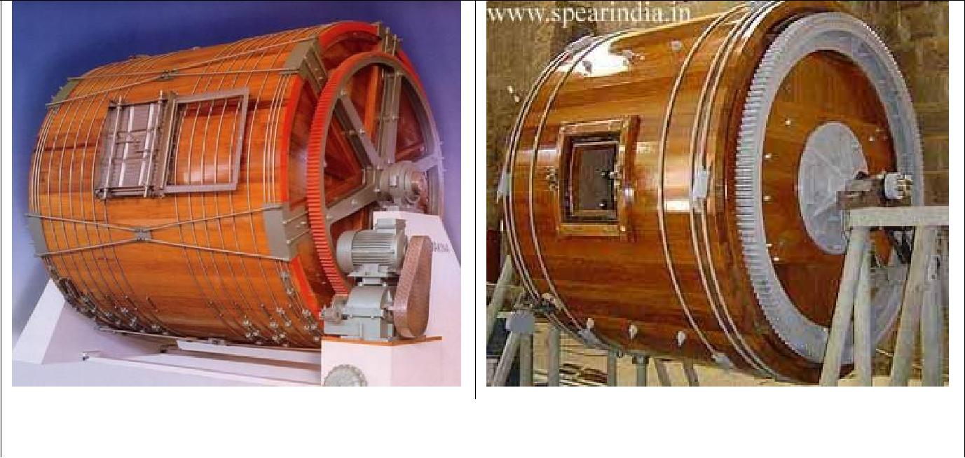

Product Description

Tanning drums, for the process lines liming, soaking, pickling, chroming, dyeing. Tree parts from african tree, hard and chemical resistant. Big gear fully machined.

Types of vessels

- Traditional drum

- Y drum

- Y disposition washing machines

- Square drum

- Paddle

- Mixer e.t.c

10

Other materials for drum construction
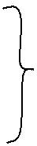
1. | Stainless steel
2. | Plastic | for dyeing, milling and laboratory work
3. | Fiberglass

Vessel's influence on mechanical action: The variables which may have an influence on mechanical action are:

- Type of vessel: Each type of vessel will have a different mechanical action on leather, needing different float relations to run or move the skins. Because most tanneries just have traditional drums, we will concentrate on them, while making some references to Y type drums.
- Size (width and diameter): The fundamental parameters which must considered in drums are their internal diameter and length. Both parameters have obvious influence in the capacity of the vessels, while diameter will define a peripheral speed at a certain angular speed.
  - Vessel speed: The speed of a drum is supposed to define different types of mechanical action movement related to the maximum mechanical action speed (mmas). Mmas is the speed at which the centrifugal effect of given leather mass will be compensated for by its weight, falling from the highest part of the vessel. A drum running at 25% of the mmas where the centrifugal effect is very low and mostly the friction is between the pieces of leather with gentle action of pegs and shelves is different from a drum running at 50% of its mmas where you’ll notice a certain fall effect but not from the highest portion of the vessel. Peg action at this speed will cause a mild bend and compression of the leather, while the low fall of the mass will generate a low hit compression. At 100% of the mmas, the mass falls from the highest portion of the vessel, generating the maximal compression. At this speed, the action of the pegs will also cause a strong compression by shock and bend. In case the speed is over 100% of the mmas, the centrifugal force will overpass the mass and so the mechanical action will be reduced with consequent energy waste. It is important to note that apart from the deformation strength with speed, the drum will achieve a certain hit frequency. In all these cases compression/release movement will generate a certain peristaltic pump effect that is one of the clue factors of penetration by mechanical action.

- Vessel load: The leather mass will be responsible for the falling hit which will generate the said compression/release mechanism responsible for the peristaltic effect. Logically, the higher the leather mass, the higher the compression and peristaltic effect. This means that the compression pressure will be a combined speed/mass effect.

11

- Internal disposition: A typical internal drum disposition may involve pegs, shelves (or a mix of pegs and shelves) and also big shelves. Pegs and shelves help the leather mass to overcome inertia. Pegs are more indicated to avoid knots but their action is more aggressive. There are different types of pegs which may vary in size and shape, being from rounded cylindrical to flat shelf-like. Shelves have reduced tearing and deformation effects. Big shelves generate a high peristaltic and compression effect at low speeds, in which case mmas cannot be applied. As we saw in point 3, a combination of speed and internal disposition will generate a characteristic mechanical effect due to the contact hit, generating a certain compression/release effect.

- Float recycling system (flux, turbulence, recycled volume): The main effect involving a recycling system in penetration is the recycling volume which will define a float-in-vessel volume which will, of course, be different to the float-in-process volume. A low float-in-vessel volume will generate a higher chemical penetration due to a higher hit pressure and the consequent peristaltic and compression effect on the leather. A high float-in-vessel volume will produce an attenuation of the hit pressure, due to the Archimedes principle with a reduction of the peristaltic and compression effect, which will reduce penetration. A low float-in-process volume means a high concentration of the chemicals in respect to the water, propitiating penetration by an osmotic effect.

- The vessel construction material (wood, stainless steel, polypropylene): The most currently used materials for drums are wood, polypropylene and stainless steel. In the experience of the tanning industry, research has not found any formal differences in penetration rates between these three types of material, just technical differences such as heat conductivity, abrasion and chemical resistance and chemical absorption by the material itself. Regarding abrasion and chemicals absorption, stainless steel and polypropylene show more advantages than wood. Both are long lasting materials with a smooth surface and are easy to clean. With reference to thermal isolation, polypropylene is slightly more efficient than wood and much more efficient than stainless steel.

- Mechanical action calculation on traditional drums The movement of the drum with the help of pegs and shelves to overcome inertia will generate an increasingly high centrifugal effect on the leather mass causing it to fall from its higher part (mmas). Proportions of the mmas can be suggested for each step of the process, depending on the desired effect we want to obtain. For example, during chrome leather dyeing, we need a high hit of the leather mass so as to achieve the maximum compression and peristaltic effect of the leather to complete penetration in the shortest time. The opposite effect will occur during the beamhouse process and particularly with lime addition, where it is important to achieve a certain friction between the skins while, at the same time, limiting the abrasion by walls of the vessel. One formula may be applied to

12

calculate the percentage of the maximum mechanical action speed to define a mechanical parameter in a certain process or experience. Big shelf drums work under a different logic: shelves in this case are not only a media to overcome inertia as was said before but a media for picking up the leather mass. In this way we may calculate the optimal speeds for each vessel and the proportions of the mmas advisable for each process.

9. Mechanical properties of Y drums: Y drums will have different movement logic. In this case, the mechanical action involves the following steps:

- Rotation of the drum with lift action;

- First fall with very low/no float;

- Rotation movement down;

- Second fall with float involving rotation of the drum with lift action;

- Rotation movement with friction.

Automation of Process vessels

The Automation System has been developed together with leading tanneries of the leather industry focusing on safety, reliability and ease of use. It is open to communicate with existing machinery and peripheral equipment. Visualization of the production plant with standard technology. The automation machine qualities are as follows.

- Easy handling

- Reliable software and hardware

- Configuration to match the general needs of a tanner

- Quick and easy trouble-shooting

- Minimal spare-part costs

- Complete control of the process

- Data evaluation of all recipe and machine events

- Checks before mistakes happen

- Check all process parameters from any point in the world

A drum pair is supplied by a heating circuit, thus ensuring ideal heating conditions for comparative trials.

The temperature range is between 20°C and 80°C. Desired |  | and | actual | values |  | can | be | controlled
separately for each heating circuit .The effective | heating | system | ensures | a | maximum |  | difference |  | of
only 2° between t he f l oat and heating circuit | temperature. A sound basis |  |  |  | for | achieving |  | your | test
results.
 | 13

Water, the most important medium of all, plays a decisive role during leather production. It is the ideal solvent for use in the leather process when the correct volumes are utilized at t he right temperature. The Dose water mixing and dosing system sets standards in celerity, precision and operational

control. The | system mixes | hot and cold water to the specified temperature and |  |  |  |  | conveys correct
volume to | the preselected | consumer. Water pressure and the intake |  |  |  | temperature are | transmitted in
real time. The computer calculate the |  |  | correct start | valve | setting f or | the independent control valves
and realizes these. The system enables |  |  | recording of | the | exact mixing | temperature after the medium
has travelled the shortest |  | possible distance. The computer then processes this value to achieve a fine

correction. A second temperature sensor ensures that temperature readings are correct . The desired temperature is achieved within a few seconds and t he water is directed into t he drum.

The control secures constant leather quality. One screen shows all important information like temperature, total running time and step running time.

IPC control can save 20 recipes composed of 500 steps and 30 processes can be entered IP Control qualities

- Can be run fully automatic without PC connection

- 20 Main recipes can be stored and edited

- Dependent and decision based recipe run

- Process sequel

- Alarm handling

- Including preparation tank control

- Fully customisable to fit all needs

- Comfortable data handling

- Optional bar code scanner

- Optional pH meter available

- Automatic water orders t o Dosemi x

- Automatic chemical orders to Chemdos

- Automatic pH Measurement orders to pH check

- Automatic orders to Weight check

LIFE CYCLE COSTS OF MACHINES

The scope of this topic is to know the Life Cycle Cost calculation methods for systems, machines and equipments.

14

Life cycle costs are summations of cost estimates from inception to disposal for both equipment and projects as determined by an analytical study and estimate of total costs experienced during their life. The objective of LCC analysis is to choose the most cost effective approach from a series of alternatives so the least long term cost of ownership is achieved. LCC analysis helps engineers justify equipment and process selection based on total costs rather than the initial purchase price. Usually the cost of operation, maintenance, and disposal costs exceed all other costs many times over. Life cycle costs are the total costs estimated to be incurred in the design, development, production, operation, maintenance, support, and final disposition of a major system over its anticipated useful life span

Abbreviations
CDP | - | Cost of deferred production
CMM | - | Corrective maintenance manhours (annual average)
CMSP | - | Corrective maintenance spare parts (annual average consumption)
MTTR | - | Mean time to repair
PMM | - | Preventive maintenance manhours (annual average)
PMSP | - | Preventive maintenance spare parts (annual average consumption)
System and Equipment Purchase Cost |  |  | The total purchase cost within a vendors scope of supply.
Installation Cost |  |  | The total cost to install the system and equipment within the
 |  |  | vendors scope of supply.
Commissioning Cost |  |  | The total cost to commission, and where necessary certify, the
 |  |  | installed system and equipment.
Insurance Spares Cost |  |  | The total purchase cost for the initial spares holding for the
 |  |  | system and equipment within the vendor’s scope of supply,
 |  |  | necessary to obtain the required system regularity.
Reinvestment Cost |  |  | The total cost to remove, refurbish or purchase, install and
 |  |  | commission systems and equipment that is predicted to exceed
 |  |  | its design life during the life of the production facility.
Man-hour Cost |  |  | The total maintenance man-hour cost required to maintain the
 |  |  | system and equipment within the vendors scope of supply. The
 |  |  | man-hour cost to include preventive maintenance, servicing
 |  |  | and corrective maintenance. The cost for corrective
 |  |  | 15

 | maintenance to include maintenance carried out offshore and
 | maintenance carried out onshore.
Spare Part Consumption | The total cost of spare parts and consumables, over the design
 | life of the system and equipment, necessary to complete the
 | predicted work load for all maintenance actions (i.e. preventive
 | maintenance, corrective maintenance and servicing).
Logistic Support Cost | The total logistic support cost predicted to be necessary to
 | support the maintenance requirements for the system and
 | equipment within the vendor’s scope of supply (e.g. supply
 | boat, diving support vessel).
Energy Consumption Cost | The total energy consumption cost for the system and
 | equipment within the vendors scope of supply. It includes the
 | cost of the fuel required to generate the power and associated
 | CO₂ tax.
Deferred Production Cost | The total cost of deferred production due to the probability of
 | failure of system and equipment.
Baseline Cost | Baseline cost data, for comparison with vendor input, will be
 | based on historic records for similar equipment within the
 | vendors scope of supply.
Life Cycle Cost Design Optimization | A computer model programmed in Excel. The model contains
and Evaluation Model | the formulas. It is structured for input of variable data and
 | calculation of results. It enables the user to evaluate and
 | optimize system and equipment design and calculate the result
 | based on Life Cycle Cost. The model also provides an option
 | to take tax considerations into account. A smaller model for
 | simpler cost calculations is also available.

There is computer model programmed in Excel which contains the formulas shown below

1. Value of money related to time

The base year for the analysis must be established. All costs must be discounted back to the present base year to take into account the time value of money. For this the following formula is applied:

16

n | S_{t}
= | --------
∑t=0 | (1 + k)^{t}
Where:

  - S_{t} = Net cost in year t. This can be assumed equal for all the years, it can vary according to production, or it can have some other given variation throughout the lifetime.

  - n = the lifetime of the equipment/function to be evaluated. When the required lifetime of the equipment exceeds the expected lifetime, the required life is used.

  - k = the discount rate/interest rate to be used for the evaluation.

- Capital cost

Capital cost is calculated by adding the following cost elements:

- Equipment purchase cost.

- Installation cost.

- Commissioning cost.

- Insurance spares cost.

- Reinvestment cost.

Where there is a deviation between when the investments are made and the base year for the evaluation, capital cost is discounted back to the base year.

3. Operating Cost

Operating cost is calculated by adding the following cost elements:

- Manhour cost.

- Spare parts consumption cost.

- Logistic support cost.

- Energy consumption cost.

For costs that is constant through the lifetime, multiply the annual cost with a discount factor f to get the cost over the lifetime.

17

 | 1 . |  |  | ∑ | m
f = (1 + k) |  |  |  | ∑
 |  | t1-t0 |  | ∑ | 1 .
^{t=1} (1 + k)t

Where:

- t0 = the base year for the evaluation.

- t1 = the time for startup of operations.

- m = Number of years in operation.

- k = the discount rate/interest rate to be used for the evaluation. a) Manhour Cost
Manhour cost is be calculated as the sum of:

- Corrective maintenance manhours.

- Preventive maintenance manhours.

- Servicing manhours.

Corrective Maintenance

The formula for average annual corrective maintenance manhours (CMM) is as follows: CMM = λ_{T} .8760 MTTR . A. M

Where:

CMM = Average annual manhour cost for corrective maintenance.

λ_{T} = Total failure rate as number of failures per hour. This includes all failures.

(Equals 1/Mean Time Between Failures).

8760 = Number of hours in a year.

MTTR = Mean Time to Repair. The time in hours it takes to repair the faulty item back to operating

condition.

A = the number of men required to do the work. This also includes the safety aspect.

M = the manhour rate.

The average annual costs shall be discounted as shown in clause 1.

Preventive Maintenance

The formula for annual preventive maintenance manhours (PMM) is as follows:

PMM = Number of times per year x Manhours x Manhour rate

18

Where:

Manhours = The number of manhours required to perform the preventive maintenance routine The average annual cost shall be discounted as shown in 1

Servicing

Calculations is done as for Preventive Maintenance. b) Spare Parts Consumption
Spare parts consumption is calculated as the sum of:

- Spare parts for corrective maintenance.

- Spare parts for preventive maintenance.

- Spare parts for servicing.

The formula for average annual corrective maintenance spare parts (CMSP) consumption is as follows: CMSP = λ_{T} x 8760 x Average corrective spares

Where:

CMSP = Average annual corrective maintenance spares consumption.

λ_{T} = Total failure rate as number of failures per hour. This includes all failures. (Equals 1/Mean Time between Failures).
8760 = Number of hours in a year.

Average annual spares = Average spares needed for repair of the equipment. The average annual cost shall be discounted as shown in 1

Preventive Maintenance (PM)

The formula for average annual preventive maintenance spare parts (PMSP) consumption is as follows: PMSP = Number of times per year x Average spare parts consumption per PM routine
Servicing

Calculation is the same as for Preventive Maintenance. c) Logistic support cost

Logistic support cost is calculated as the sum of all logistic support activities necessary to maintain the equipment. The average annual cost shall be discounted as shown in 1

Life cycle cost for the system and equipment evaluated equals the sum of the following cost elements:

• Capital Cost.

19

- Operating Cost.

- Cost of Deferred Production.

MACHINE COMPONENTS Three phase motors

An electrical motor is such an electromechanical device which converts electrical energy into a mechanical energy. In case of three phase AC operation, most widely used motor is Three phase induction motor as this type of motor does not require any starting device or we can say they are self starting induction motor. Three-phase electric power systems have at least three conductors carrying alternating current voltages that are offset in time by one-third of the period. Nearly all tannery machine drives are powered by the three phase motor as this is the most cost effective medium for the purpose.
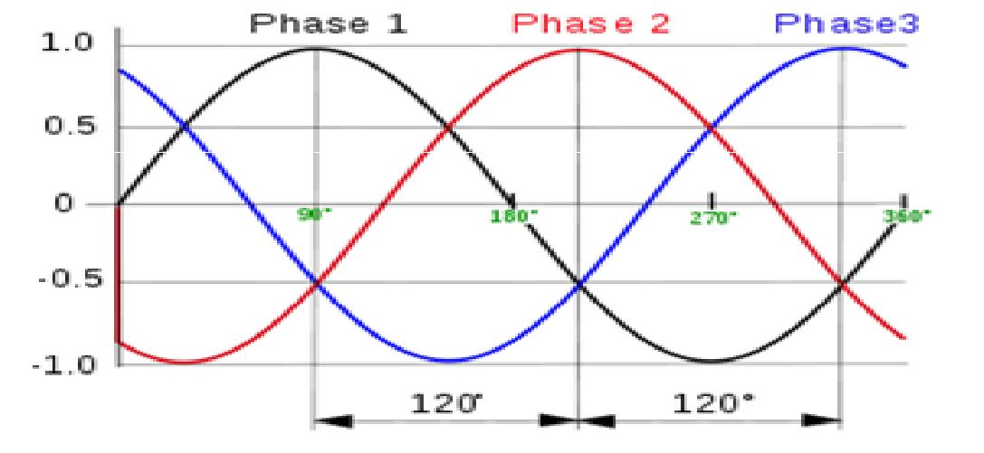

The stator of an induction motor consists of a number of overlapping windings offset by an electrical angle of 120°. When the primary winding or stator is connected to a three phase alternating current supply, it establishes a rotating magnetic field which rotates at a synchronous speed. The direction of rotation of the motor depends on the phase sequence of supply lines, and the order in which these lines are connected to the stator. Thus interchanging the connection of any two primary terminals to the supply will reverse the direction of rotation.

The stator is the stationary part of a rotary system, found in electric generators, electric motors, sirens, or biological rotors.

Starters control boxes

20



Start and Stop switch

Starting, stopping and reversing the three phase cage induction motor.

Starting –Direct on line starting is generally employed only on motors rated up to 15HP when full voltage three phase power is supplied directly to the stator terminals, manually or automatically via contactor. When this method is adopted the starting current is about four to seven times the rated current. Torque at starting is 125% of full load.
Reversing –Reconnecting the supply for reversed direction of rotation results in rapid deceleration to stopping followed by reversing. When fast stopping is required a position sensor gives an automatic signal to disconnect the supply when the motor has reached rest point.
Speed control –The speed of the induction motor is governed by the supply frequency and the number of poles and it follows that if it is connected to a controllable frequency supply, speed regulation is possible. Controls, electrical and electronics –Modern tanneries are equipped with on board control gear mostly fitted into metal or plastic housings with electrically interlocked access, containing all the control elements. Developments are in the direction of providing such machine control gear with remote programming and control ports enabling the machines or a series of machines to be operated from central control rooms. Controls are an integral part of a submersible motor power system. Rigorous component testing ensures the most robust products in the industry.

- Contactors to start and stop motors

- Relays to switch operating currents.

- Overload devices to protect motors from excessive currents.

- Fuses to protect from damage due to short circuit and provide for earth protection.

Power transmission

Power transmission is the movement of energy from its place of generation to a location where it is applied to performing useful work.

21

Power is defined formally as units of energy per unit time. In SI units:
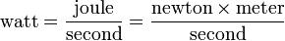

Since the development of technology, transmission and storage systems have been of immense interest to technologists and technology users.

Electric power transmission.

This is the bulk transfer of electrical energy, from generating power plants to electrical substations located near demand centers. This is distinct from the local wiring between high-voltage substations and customers, which is typically referred to as electric power distribution. Transmission lines, when interconnected with each other, become transmission networks. The combined transmission and distribution network is known as the "power grid", or just "the grid". In Kenya, the network is known as the "National Grid".

Speed reduction.

Combinations of gears used to reduce the input speed (as of a marine turbine) to a lower output speed (as of a ship's propeller)
Prime movers = motor (electrical) 2800 rpm

1400 rpm –most common

1200 rpm

The shaft that turns a machine does not always match the speeds available from any motor or motor and gear reducer combination available.
In speed reduction, we use;

1) Pulleys or belts.

Driven

Driving d –diameter of A
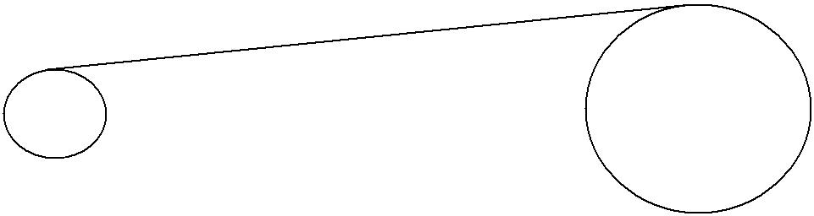
N –speed of A in rpm

A ^{d} D B D –Diameter of B
NA N –Speed of B in rpm

NB

dNA = DNA

Liming drum NB = 3rpm

22

Tanning drum |  | NB = 10rpm
Fleshing machine |  | NB = 300rpm
Example | NA | = 1400rpm

  - ?

- Sprocket and chains TA
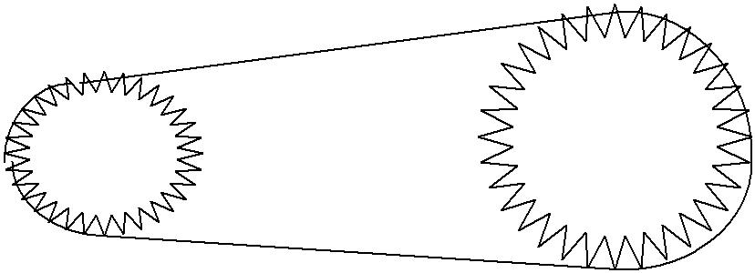
A

NA

3) Spur Wheels and pinions
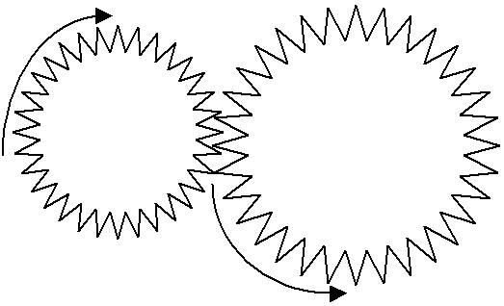

A

B

T_{A}N_{A} = T_{B}N_{B}

4) Gear box (3 shaft)

d | = | 20cm
D | = | dNA | = 20cm x 1400 = 2800cm
 |  | NB | 10
 | TB

B | TNA = TNB
NB
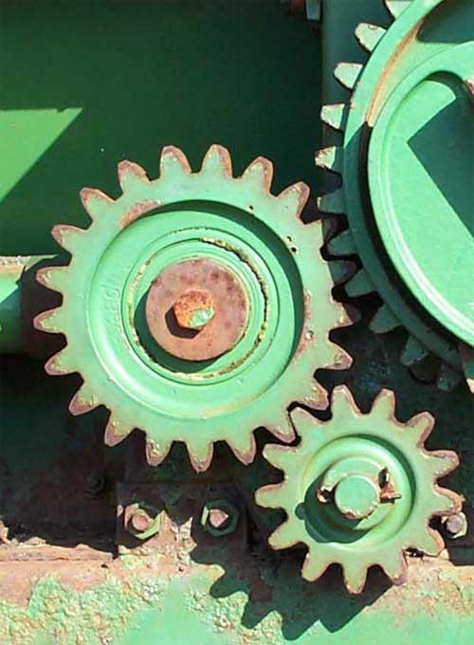

Driving
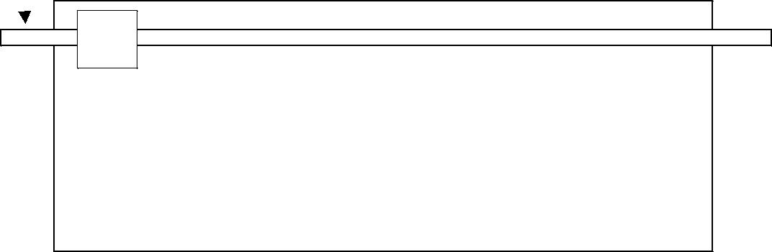
A

 |  |  |  |  | T_{A}N_{A} | = T_{B}N_{B}
 |  |  |  |  | N_{B} = | N_{C}
 | B |  | C |  | N_{B} = | N_{C}
 | B |  | C |  | T_{C}N_{C} | = T_{D}N_{D}
 |  |  |  |  | 1400 x 10 = 700
 |  |  | D |  | 20
 |  |  | D |  | 700 x 10 = 350
 |  |  |  | 20

Components of a gear box

- Grub screw –Disconnects to protect the drum

- Pulleys or belts –Adjusts tension so they can slip or break

- Pinions/cogs –Made out of polymer

  - Sacrificial

  - Cheap or replacement is cheap

  - Quiet –not noisy.

Hydraulic systems

An industry requires 1) Objects or substances to be moved

2) Force to hold shape or compress products The industrial prime movers use;

- Electricity (electrical equipments)

- Hydraulic –liquids

- Pneumatic –gasses

Fundamental principles

Pascal’s law states that pressure in an enclosed fluid can be considered uniform throughout the system.

P=F/A |  |  |  | Pressure |  |  | = |  | Force
 |  |  |  |  |  |  |  |  | Area
 | 5kg
 | 2cm² |  |  |  |  | 1.5m² |  |  |  |  | 8kgf
 |  |  |  |  |  |  | F37500f |  |  |  |  | 2cm² | 2000kgf
100cm² |  |  |  |  |  |  |  |  |  |  |  |  | 5000cm² | Mechanical Advantage = 2000kgf
 |  |  |  | -2 |  |  |  |  |  |  |  |  | 5000cm² | Mechanical Advantage = 2000kgf
P = 2.5kgf.cm |  |  |  |  |  |  |  |  |  |  |  |  |  | 8kgf
F = 250kgf
 |  |  |  |  |  |  |  |  | 24
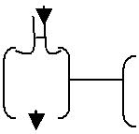

Energy must be considered (and assume fluid is incompressible) LHS –moves down 100cm = 200cm³ of liquid transferred RHS –moves up by 0.04cm

Boyle’s law
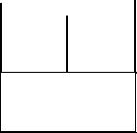
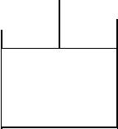

P₁V₁ ⁼

P2V2

P₁V₁ = P₂V₂ (if there is no temperature change)

Hydraulic
= 250

P₁V₁ = P₂V₂

T T

- The liquid is expensive and messy therefore piping acts as a closed loop.

- High pressure pumps cannot operate continuously

  - Pump will fail

  - Pipes will fail

  - Need pressure regulation

- Speed control is easily achieved by regulating the volume flow rate

- Precise control at low speeds is one of the main advantages of hydraulic systems

- Pump is turned by an external power source –AC induction motor with overload protection.

- Hydraulic fluid must be clean –filters used to remove dirt particles.

- Leaks are unsightly and dangerous (slippery) and bad for the environment and flammable

The hydraulic pump

- Takes oil from the tank

- Delivers it to hydraulic circuit.

- Raises the pressure level to the desired level

- Generally 3-phase motor (-1500rpm –50htz)

- Usually positive displacement pumps

- Fixed volume delivered regardless of pressure at outlet port

- Gear, vane or piston

Pressure regulation

25

Simple regulator

System pressure
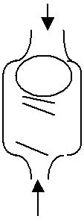

Ball
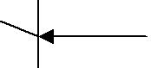Spring

Return to tank

Hydraulic fluids

Liquid is used to convey energy and produce the required force.

- Water –BAD because it has

  - High freezing point

  - Expands when it freezes

  - Corrosive nature

  - Poor lubrication

  - Low viscosity-leaks

- Modern fluids –Good because it

  - creates a seal with moving parts

· reduces friction Lubrication
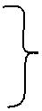
- reduces premature wear

- is ideal operating temperature of about 50ºC –requires preheating

- removes heat where generated

- must be compatible with the system.

- is chemically stable

- is bound to be expensive

Problems

- Oxygen in air

  - damages fluids (oxidation)

  - changes oil characteristics

  - oxidation products are acids

- Oil can overheat and char

- Bearings can seize

- Use additives to prevent or minimize this (added cost)

26

- Leakages (flammable)

A high viscosity fluid is sluggish –energy loses occur

–seals well

Must find a balance

Air compressors

Majority use compressed atmospheric air. A pneumatic system is open and

- fluid is free

- vented back into the environment

Pressure of a liquid may be raised to a high level quickly, and pressure rise in a gas takes time.

In hydraulics

- fluid is stored at atmospheric pressure and compressed when needed

- Pressure is quickly and easily controlled

In pneumatics

- Slow response

- Necessitates storage of compressed air of the required pressure in a reservoir vessel

Bladed cylinder machines

The bladed cylinder machines are unhairing, fleshing, scudding, setting and shaving.
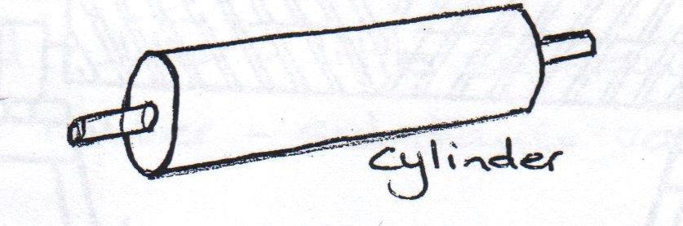
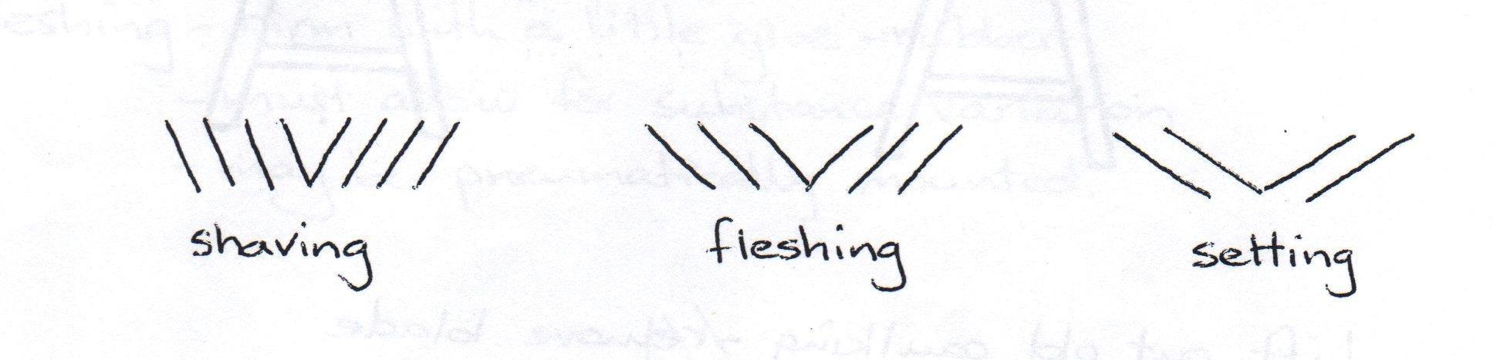

Angle of pitch is the angle at which left blade meets right blade at the centre of the cylinder.

27

A small angle of pitch requires a longer blade. Bladed cylinders must be completely symmetrical to ensure uniform treatment. Bladed cylinders must remain fixed and rotate in position. They need high precisions for complete uniformity. The angle of the blades helps spread the skin.


Reblading cutting cylinder

- Support cylinder on a bench or trestle.
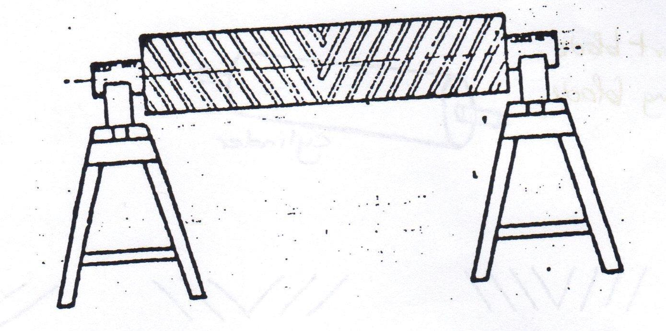

blade Caulking
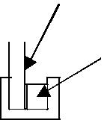
· Lift out old caulking –remove blade

- Wire brush cylinder body and grooves to remove rust and scale.

- Feed new blade into groove, cut off and grind end as required.

- Caulk in blades by hand (all caulk should be on the front or leading side of the blade)

- Blades can be stainless steel or brass (2.0, 2.7 or 3.3mm)

- Brass caulking –malleable enough to hammer in and hold blades in place.

Pressure rollers

Regulate the space and pressure of action on the leather.

- Shaving –hard rubber –very little substance variations.

- Setting –hard rubber –little substance variations

– softer rubber –substance variations.

- Fleshing –Firm with a little give rubber

– Must allow for substance variations

28

– May be pneumatically mounted
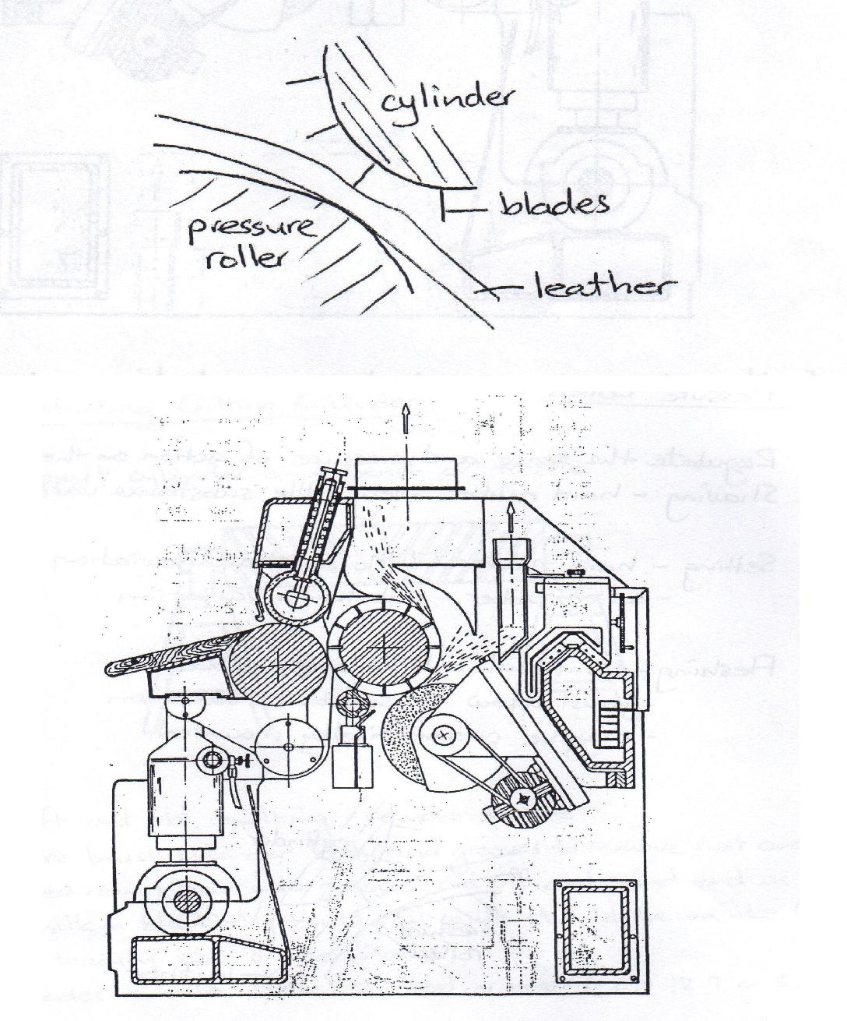

- Cutting knives mounted on a rotating cylinder

- Grinding keeps the edges sharp

- Shaving levels the thicker areas for an even thickness.

29

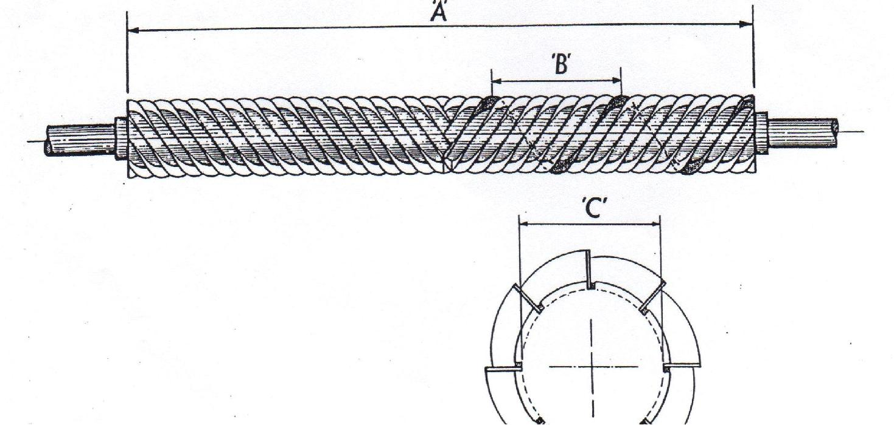

- Shavings removed are relatively useless

- Leather must be flexible and pliable to bed down flat on the feed rollers

Basic components of a shaving machine

Fleshing
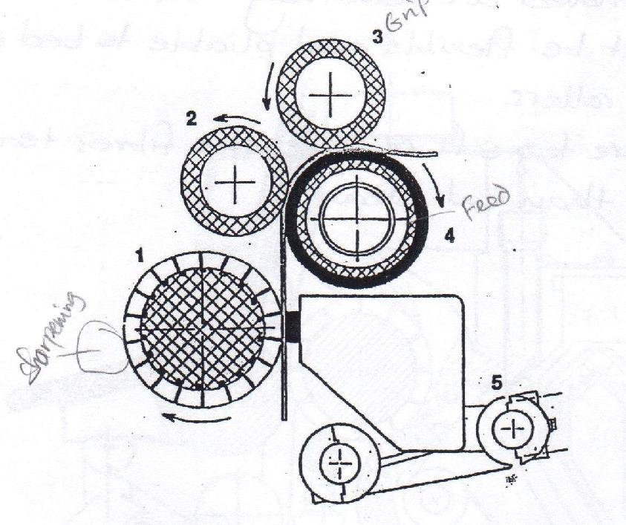

- Cutting cylinder has sharp square-ground blades

- Arranged in opposed double helical form

- Spreads the skin as it cuts

- Sharpening stone keeps blades sharp.

30

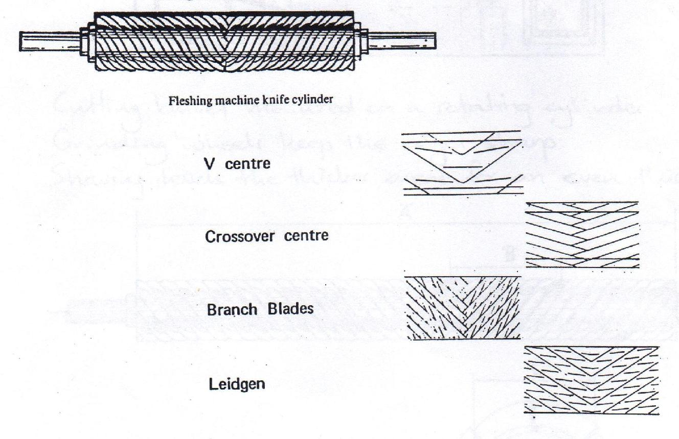

- Lime fleshing is easier than green fleshing

e.g. | Lime fleshing: shorter blade (22inches), larger angle of pitch.
 | Green fleshing: longer blade (44inches), smaller angle of pitch.
Grip roller

- Hold the hide firmly

- Feed the hide through the machine

- Slipping causes uneven substance, holes and rips - Normally grooved

Feed roller

- Rubber cylinder roller mounted on a hydraulic delivery system.

- Creates pressure for grip rollers Sharpening block

- Carborundum sharpener mounted on a hydraulic delivery system

- Creates pressure for grip rollers

Normal fleshing machine should flesh about 120hides/hour Through feed fleshing machine should flesh about 300hides/hour

Setting out Machine

31

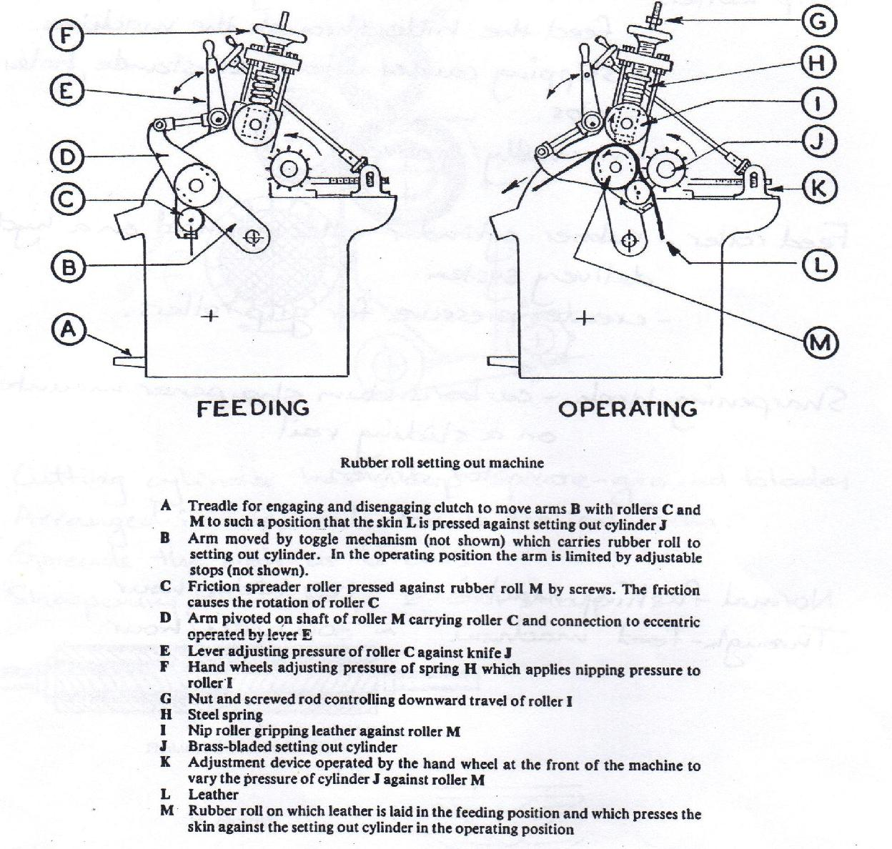

- Rubber roll machine

- Rotating blunt helically-bladed cylinder often combined with sammying.

- Stretches out the pelt and squeezes out water (60%)

- Obtains a smooth, flat, crease free surface

32

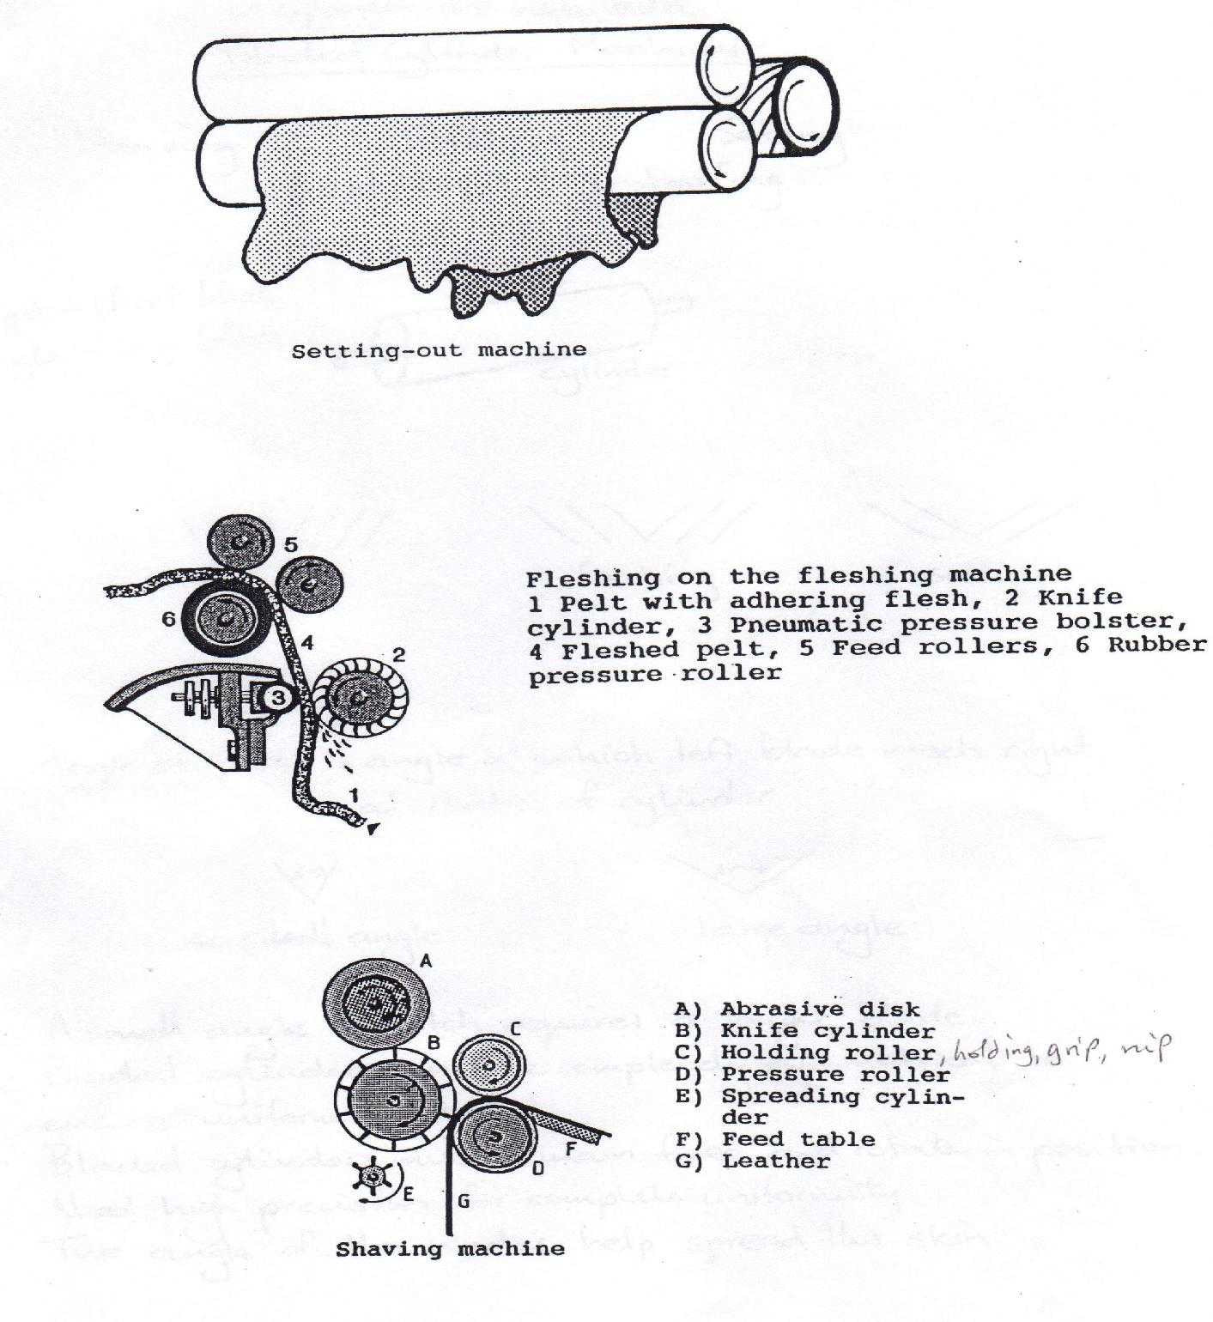

Band knife splitters

The modern band knife splitting machine has a flexible knife in the form of an endless band that travels at high speed over a pair of large pulleys. Rollers grip the leather and propel it forward into the knife, slicing the leather into two layers. By adjusting the level of the rollers, almost any thickness can be split.

The basic band knife splitter consists of;

33

- Large driven pulleys to carry the band knife at high speed

- Feed roll group

- Blade sharpening group

- Vacuum group for grinding dust and splitting waste Section roller’s work is;
- | Drives leather into blade | Gauge roller
- Made of individual rings |  |  | section
- | Pushes into rubber roller
- | Pushes into rubber roller | Rubber
- Compromises for varying thickness

Bevel –Slope from the horizontal often referring to splitting knife

Gauge roller
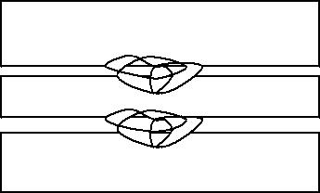

Rubber

bevel
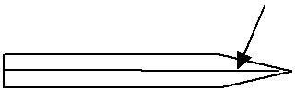

Process Vessels Drums

Timber construction fitted with drive system of pinion and gear ring driven by ‘v’belt and electric motor. These wooden drums are preferred in the beam house operations. Drum doors are now constructed using stainless steel to solve the problem of leaking when timber doors are used.
Stainless steel and plastic drum construction in the market today have not gone beyond 3m diameter by 2.5m length mark and has been limited to dyeing, milling and laboratory work.

Paddles

Paddle wheels can be built into pits or concrete troughs but the most commonly built paddles are vessel and rotor is timber built

Dryers

Drying occurs when the water in the skin evaporates into the surrounding air.

- Hanging is drying in space by hanging using hooks on rails. This allows the leather to lose moister freely while not under tension. Good for gloving, chamois and clothing leather.

- Drying under tension by the use of;

  - Nails –Nailing the leather on boards after setting out well will enable the leather to be stretched out and the shape adjusted to some extent. Care should be taken for shrinkage strains. Drying is slow and limited to one side as the board inhibits drying on one side.

34

- Toggling –Similar as nailing but the wooden board is replaced by toggling frames of either of heavy gauge wire mesh or perforated metal. Advantages over nailing are

  - Give good air circulation on both sides of the leather to give rapid drying.

  - Have longer life

  - Are easier to keep clean

  - Give rise to less fire risk

c) Paste drying –Wet leather is stuck, grain side, to a glass plate using thin starch paste after a well slicking on the glass plate. The glass plates and leather are carried on the overhead rails through a long drying tunnel. Suitable where a flat grain is required as in corrected grain.

Finishing machines and presses

Staking: This is the principal softening operation which may take different forms for different leathers. Some forms of the operations are;

- Hand staking –This consists of pulling the leather (flesh side in) over a steel blade fixed to a stout wooden stake and flexing it under tension at a very acute angle. Used mainly for glove leathers, reptiles and fur skins.

- Perching –The leather side is clamped to a wooden clamp and is flexed by scraping action on the flesh side with a moon knife (or arm perch). Used mainly for furs, wool and very soft skins.

- Slocomb staking machine –A machine with two jaw arms which open as it moves them forward and closes and the leather (being held by the operator on one side) is trapped between the top roller on the jaw and the blades on the bottom jaw. As the arms move back, the leather is stretched and flexed at an acute angle. Used for softer types of mineral tannage, particularly gloving.
4) Rotary staking machine –Leather is held against a bolster |  | Blunt rotating blade
and the blunt rotating blades of the working cylinder which
scrape against the flesh side | of the leather and flexing it | leather
accordingly. Advantage over | Slocomb is high output, flat
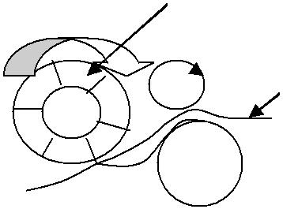
skin production and versatility. 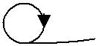 Buffing: This is the grinding of the leather surface using an abrasive and is akin to sand papering.

There is a great variety of finishing processes designed to enhance the appearance of the leather and only the more common are described. Other mechanical finishing processes include wheeling, brushing, rolling and glazing, ironing, embossing and plating.

35

Materials of construction.

Cast iron properties

- Resistance to compression

- Resistance to chemical attack

- Heat conduction

Advantages of cast iron in sammying machine

- Compression of rollers

- Squeeze water out

- Resistance to stress

Advantages of cast iron in fleshing machine

- Resistance to sulfur corrosion attack

- Resistance to other chemical attack

- Resistance to stress

Machine safety legislation

A comprehensive standard of ‘Tannery machines Safety requirements’developed in UK by the European committee for standardization, published as an EN(European Norm) standard making numerous references to EN standards that detail individual and more general safety requirements and systems. EN standards deal with design and function of safety devices, sometimes indicating alternatives. The device adopted must meet what is specified in the standard. Compliance with the requirements is mandatory in the member countries, but the member country machinery manufacturers tend to fit in the safety systems even when exporting their equipments to non member countries.

While it obviously is always the responsibility of the user to ensure ongoing effectiveness of the safety systems installed on all types of the equipment in operation, a regular check of the safety elements on machines, because of the complexity, should be scheduled. Vital areas to be checked in this way should include:
- Visual examination of the devices.

- Verify the interlocks and self checking systems are functional.

- Verify that safety switches operate correctly.

- Verify the time taken to stop dangerous motion after tripping device.

- Check guarding of electrical equipment.

- Verify that protective devices as such do not represent danger.

36

- Where applicable test from time to time that the equipment still complies with noise emission regulation.

Services in general

Water from | - | Municipality
 | - | Rivers, lakes etc
Compressed air | - | Compressor pumps
Steam (hot water) - |  | Boilers
Hydraulics | - | Pumps (either diesel or petrol)
Pneumatics | - | Pumps (compressors)
Electricity | - | Drives motors –converts electrical energy to mechanical energy.
 | - | Generators converts mechanical energy to electrical energy.

Boilers in tanneries

Boilers in tanneries are used for:

- Drying

- Hot water

- Space heating

- Steam –heating water

Boilers take energy in its available form and convert it to a form which can be conveniently used i.e.

- Potential energy in coal → heat in tannery.

· Gas → mechanical energy for electricity

Three main types of boilers

- Fire tube or shell type –Water contained in a cylinder or shell with tubes containing hot gases passing through

37

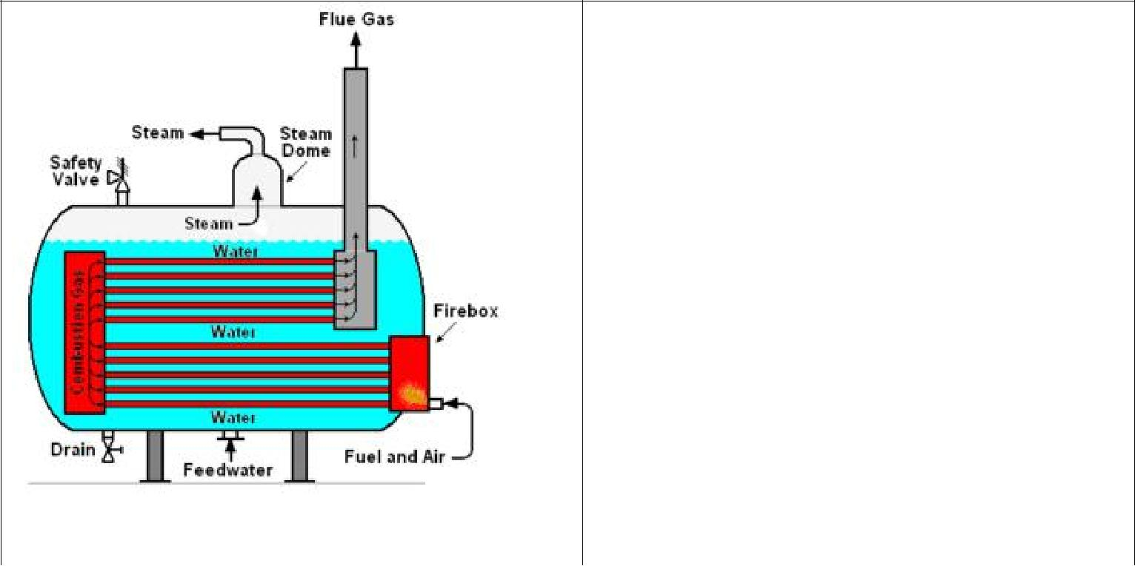
Shell
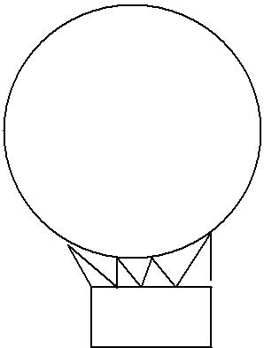

Water

Fire

Fire tube | Shell

- Water tube boiler –Water is contained in small diameter tubes connected to water system and hot gases come into contact with the external surface.
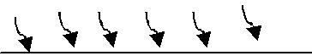
Water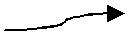
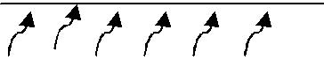

High heating surface gives good overall thermal efficiency

Efficiency is improved by - Super heater

  - Economizer

  - Air heaters

- Straight tubes –Good for cleaning and replacement

b) Bent tubes –More flexible in heating surface layout.

–More difficult to clean and replace c) Forced circulation –Thinner and lighter tubes

–Increases efficiency

–More compact

- Hot water boilers

  - Heating boiler (sectional boiler)

  - Domestic boiler

38

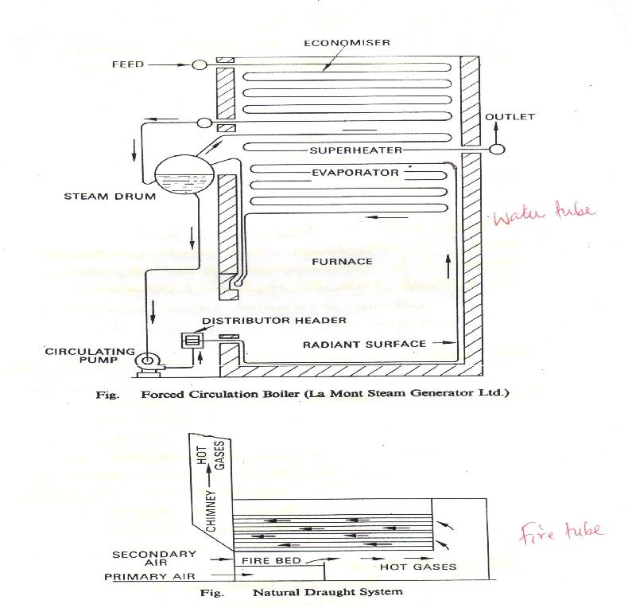

39

Fire tube vs Water tube

Fire tube |  |  |  |  | Water tube
· Limited in size and pressure |  |  |  |  | · | Less likely to explode
· Large water and steam capacity |  |  |  |  | · Obtains steam more quickly
· | Simplicity |  |  |  | · Occupies less ground space
· | Low cost |  |  |  | · Assembled on site –easy to transport
· | Low maintenance cost |  |  |  | · Working safety margin is smaller
· | Simple operating conditions |  |  |  | · Feed water purity is very important.
· Bulky –difficult to transport
· Restricted combustion space therefore limited
 | choice of bunner
Boiler terms
Economiser |  | –A heat recovery appliance
 |  | –Pre heats feed water
Flue gases |  | –Products of combustion
 |  | –H₂O, | CO_{2,} CO, SO_{2.}
Air heaters |  | –Pre heat air for combustion
 |  | –Higher furnace temperatures
Drought |  | –Provides an adequate supply of air for combustion |  |  |  |  | Small pressure
 |  | –Draws hot air through the system |  |  |  |  | difference
 |  | –Natural or mechanical
 |  | –Induced vacuum or |  |  |  |  | Balanced
 |  | –Forced vacuum |  |  |  |  | combination
Fuels |  | –Substance that burns easily in combination with oxygen
 |  | –Available at reasonable cost
 |  | –Available in large volume
 | Solid fuels |  |  | – |  | gross calorific value
 |  | –Coal + coal derivatives |  | – |  | 33MJ.kg⁻¹
 |  | –Wood |  | – |  | 20MJ.kg⁻¹
 |  | –Lignite
 |  |  |  | 40
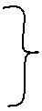
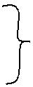

–Peat

Liquid fuels

–Light fuel oils

–Heavy fuel oils

–Paraffin

–Coal tar oils Gaseous fuels
–Coal or town gas – ≈55.5 (38MJ⁻³)

–Natural gas Electricity

Calorific value –Heat given out during the complete combustion of a unit quantity of fuel. Ignition temperature –Lowest temperature at which combustion takes place.

Flame temperature –Highest temperature in combustion. Ignition –Commonly used spark

Boiler efficiency –How well the available heat in the fuel being burnt is transferred to water –this can only be tested after the boiler has settled to running conditions.

Boiler thermal efficiency | = | Heat output
 |  | Heat input
 | = | Heat taken out by water to produce steam
 |  | Heat given up by fuel while producing steam
 | = | W(hf +qhfg –hw)
 |  | GCV
 |  | W = weight of steam produced per kg of fuel
 |  | (hf +qhfg –hw) = Quantity of heat taken up per kg of water.
 |  | GCV = Gross calorific value

Equivalent evaporation

- Common measure between boilers to allow for the wide differences in working conditions.

- ‘equivalent evaporation’from and at 100ºC

- Common denominator of boilers

41

- Evaporation produced under standard conditions from feed water @ 100ºC and at 101.3kPa.

- The heat required to produce 1kg of dry steam under standard conditions = latent heat = 2257KJ known as “standard evaporation unit”

 | Heat available for producing steam per unit quantity of fuel
Equivalent evaporation unit = | under working conditions
Equivalent evaporation unit = | Standard evaporation unit

We can only compare boilers using the same fuel. Higher E.E.U (Equivalent Evaporation Unit) is better efficiency for producing steam.

Feeder water Systems

Water feeders protect boilers by maintaining a safe water level. Low water cutoffs work in coordination with water feeders to detect the fluid level in hot water and steam boilers. If water level falls below the minimum safe operating level, the water feeder is initiated. Water feeders can be automatic (electric) or manually operated. Electric water feeders eliminate the need to manually add water to the boiler. These water feeders are used for low pressure steam boilers with a cold water feed. Electric water feeders detect fluid, expose leaks, and provide the necessary information needed to diagnose a problem. Mechanical water feeders are used for hot water and low pressure steam boilers with a cold water feed. Mechanical feeders contain a float which responds to the water level in a boiler. These units are quiet, durable and feature an isolated feed valve which minimizes lime and scale build-up.

ROLLER COATER

A coating is a covering that is applied to the surface of an object, usually referred to as the substrate. The purpose of applying the coating may be decorative, functional, or both. The coating itself may be an all-over coating, completely covering the substrate, or it may only cover parts of the substrate. Paints and lacquers are coatings that mostly have dual uses of protecting the substrate and being decorative, although some artist’s paints are only for decoration, and the paint on large industrial pipes is presumably only for the function of preventing corrosion. Roll coating machines are commonly used for the application of a liquid to the surface of a substrate. Roll coaters can be used to apply liquid adhesives, paints, oils, and coatings such as varnish or clear finish coats. Roll coaters can take many forms, from simple paint rollers to sophisticated coating machines with multiple rollers.

42

Synchro (forward) –This is the roller coater with engraved cylinder for printing patterns on materials. This roller coater has negative engraved cylinders to deposit coating material on the leather.
Doctor blade Material Application cylinder
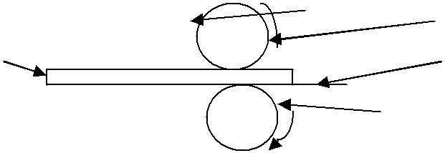
Leather Conveyor

Support roller

The speed of the conveyor and peripheral application cylinder are the same and move in the same direction. Reverse roller coater –A roller coater with positive engraved cylinder for depositing padded materials on leather.
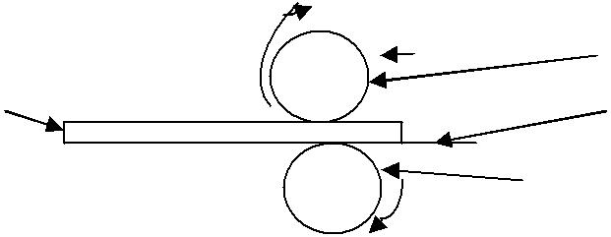
Doctor blade 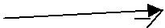Material Application cylinder

Leather Conveyor

Support roller

Movement of application cylinder and conveyor are opposite. Application cylinder presses on the leather to give a padding effect

Stucco or render is a material made of an aggregate, a binder, and water. Stucco is applied wet and hardens to a very dense solid. It is used as decorative coating for walls and ceilings and as a sculptural and artistic material in architecture.

Stucco roller coater:

- Has a spiral groove to deliver the material only to the places it is required, thus saving on the application material.

- Has photoelectric engraved cylinder for effecting desired patterns on the material

- Has positively engraved cylinders to deposit the application material in the grooves to the leather material.

- Has negatively engraved cylinders to deposit application material from the grooves to the leather material. 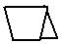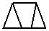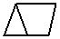

Advantages of roller coater over conventional spraying

- Saves the application material.

43

- More uniformity and better distribution of pigments and chemicals on the entire leather surface also including light weight areas.

- Better coating efficiency and it is also possible with a single pass to correct dark tones to lighter tones.

- Use of chemical product with no water added (higher percentage of dry components).

- Catalyst mixing in line immediately ahead of the feed pump to optimize chemical consumption.

SAFETY OF SERVICES Backup Power Source

During the time of energy lose from the major source there should be a backup power generator reserved to operate in the time of such a sudden power lose. Therefore, no matter how it happens, there is no reason of stopping production processes due to such causes of power interruptions.

Water Resource

Tannery consumes a lot of water for its production. Relying on one source of supply of this commodity might be disastrous to the industry, further more the cost of water supplied by the Municipality may not help the company break even. There is need for the development of a deep underground water well, for the purpose of production process consumption and other related purposes of the Company. There should also be a water reservoir which can perfectly serve for one month of production when sudden interruptions occur in the supply of the regular water from the source.
The treatment and conditioning plant for pickling – tanning wastewater to be reused in the industrial process should be equipped with the following systems:
- Wastewater channeling.

- Wastewater pre-treatment and pumping to the homogenization basin.

- Treatment of the pickling-tanning bath to be reused by means of a flotation system for the elimination of fat and a clarifier to settle all the suspended leather particles.
- Storage, conditioning and control of the characteristics of the bath to be reused.

Maintenance department

Tannery machinery mechanics and maintenance workers maintain and repair tannery equipments and other industrial machinery, such as conveying systems, production machinery, and packaging equipment.

Installation

44

If machines are to perform well over extended periods, optimal alignment and correct mounting are equally vital. Correct installation not only means good product quality, but often reduced energy consumption as well. Company workers install, dismantle, repair, reassemble, and move machinery in the tannery, power plants, and construction sites.

Commissioning

The main objective of commissioning is to effect the safe and orderly handover of the unit from the constructor to the owner, guaranteeing its operability in terms of performance, reliability, safety and information traceability. Additionally, when executed in a planned and effective way, commissioning normally represents an essential factor for the fulfillment of schedule, costs, safety and quality requirements of the project.

Fault finding

The act of pointing out faults, especially faults of a petty nature or an investigation (fact-finding). Fault finding is an extensive experience which involves quick designed tests to uncover the faults in the machinery system, and then explain the problem, consult the management in clear, understandable terms and take the correct course of action to resolve the issue.

Spare parts

Every manufacturing company should have a record of their consumables in terms of spares, so as not to waste time in procurement of spares which are replaceable on regular basis. This will help in time wasting during simple breakdowns.

TANNERY LAYOUT AND DESIGN

Leather manufacture is a complex process and it takes concentrated planning to turn an initial concept into a modern tannery. A wide range of skills and experience are required for projects of this type. Preliminary planning ensures cost savings, reduced time, elimination of costly mistakes and process optimization.

Most tanneries in the World today perform two functions, namely, processing the hide to pelts and tanning the pelts to the finished product, leather. Tanning of leather can be accomplished by any of the following well known processes: vegetable, alum, chrome, oil an formaldehyde. The two most widely used today are the vegetable and the chrome.

45

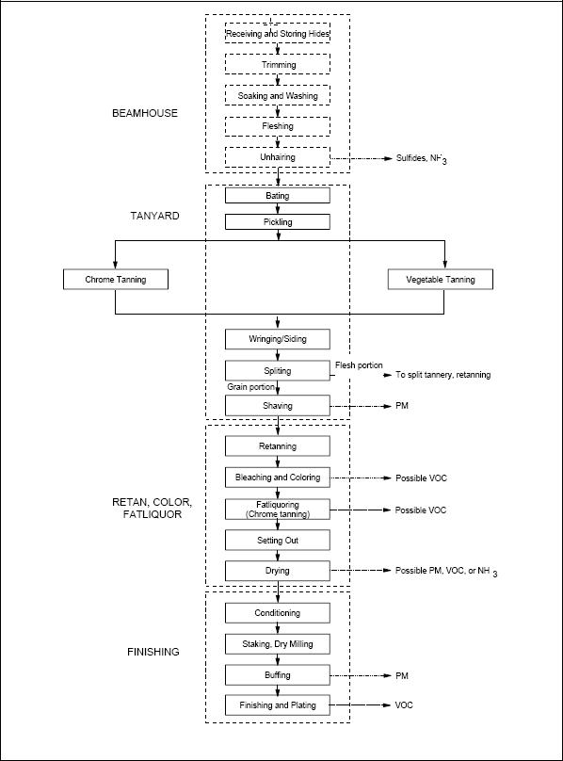

Capacities and throughputs for specific productions

Throughput is the movement of inputs and outputs through a production process. Without access to and assurance of a supply of inputs, a successful business enterprise would not be possible. Throughput can be best described as the rate at which a system generates its products / services per unit of time. Businesses often measure their throughput using a mathematical equation known as Little's Law, which is related to inventories and process time: time to fully process a single product.

Using Little's Law, one can calculate throughput with the equation:

,

Where, I is the number of units contained within the system, Inventory; T is the time it takes for all the inventory to go through the process, Flow Time; and R is the rate at which the process is delivering throughput, Flow Rate or Throughput. If you solve for R, you will get:

46


The machines can be set up for two types of production workflows and material handling: With the standard set-up, the entire working area is available for processing once the material is loaded/unloaded. In a tandem set-up on the other hand, the working area is split in two halves, making it possible to load/unload materials while the machine continues in different sections continues in line. This configuration provides the basis for non-stop production and delivers maximum throughput.

Dimensions of machines

Dimensions of tannery machines fall into different categories depending on the area of operation which also dictates the raw material used not excluding the product specifications. Raw materials from Germany cannot be compared with raw materials from Kenya –the latter being smaller compared to the former.

 | Machine type | Dimensions
1. | HYDRAULIC FLESHING MACHINE | 1600, 1800 and 2100 mm
2. | HYDRAULIC SETTING-OUT MACHINE | 1800 and 2100 mm
3. | SPLITTING MACHINE | Working width 550 mm
4. | HIGH PRECISION HYDRAULIC SHAVING MACHINE - | 1000, 1300, 1800 mm
 | Special versions of the shaving machine, equipped with
 | extended feeding table and feed roller, allow the shaving of
 | whole hides.
5. | ELECTRONIC SHAVING MACHINE | 1800, 2100, 2400 mm
6. | WET BUFFING MACHINE | 1500 mm
7. | STAKING MACHINE | 1700 mm
8. | POLISHING MACHINE | 600 mm
9. | BUFFING MACHINE | 800, 1300, 1800, 2200, 2700, 3200

Service requirements

Service requirements for a tannery are;

- Water

- Electricity

- Compressed air

- Steam (hot water)

47

- Power –Electricity

  - National grid.

  - Generators

  - Solar power, wind, water.

  - Batteries

  - 2, 3 phase, (AC or DC)

CRITICAL PATH

Longest sequence of activities in a project plan which must be completed on time for the project to complete on due date. An activity on the critical path cannot be started until its predecessor activity is complete; if it is delayed for a day, the entire project will be delayed for a day unless the activity following the delayed activity is completed a day earlier. Critical Path Method (CPM) is commonly used with all forms of projects, including construction, aerospace and defense, software development, research projects, product development, engineering, and plant maintenance, among others. Any project with interdependent activities can apply this method of mathematical analysis

Basic technique

The essential technique for using CPM is to construct a model of the project that includes the following:

- A list of all activities required to complete the project (typically categorized within a work breakdown structure),

- The time (duration) that each activity will take to complete,

- The dependencies between the activities and,

- Logical end points such as milestones or deliverable items.

Using these values, CPM calculates the longest path of planned activities to logical end points or to the end of the project, and the earliest and latest that each activity can start and finish without making the project longer. This process determines which activities are "critical" (i.e., on the longest path) and which have "total float" (i.e., can be delayed without making the project longer).

48

